Bring Your Dead Zones Back to Life



Comcast

Team 5 - xFi Xperts

Sarah Whynott, Max Sallee, Samantha Thompson, Noah Winton, Lilah Cashion, Nickolas Coffey, Brooke Gallagher, Nolan Danus & Cara Keller

Table of Contents

1. Executive Summary (Nick, Brooke) #
2. Summary of Marketing Problem (Brooke) #
3. Marketing Objectives (Brooke) #
4. Company and Market Analysis (Cara, Brooke, Nolan) #
5. Key Insights (Lilah) #
6. Marketing Strategy (Sarah) #
7. Product (Nick, Lilah) #
8. Price (Lilah, Samantha) #
9. Distribution (Max, Lilah) #
10. Branding Strategy (Cara) #
11. Promotional Schedule (Max, Samantha, Cara, Nick) #
12. Detailed Marketing Budget and ROI (Max, Samantha, Cara, Nick) #
13. Summary and Conclusion (Cara) #
14. Citations #
15. Appendix #

Executive Summary (Nick, Brooke)

As a result of the sustained rise in remote work set off by the COVID-19 pandemic, the demand for a reliable home internet connection is higher than ever. While it appears that the worst is behind us and things are getting back to normal, many companies are choosing to have their workers stay remote (Adnams, 2021), meaning that this heightened demand is here to stay. But, as consumers use the Internet more frequently and for more important tasks, a number of problems are pushed to the forefront, especially unstable connections throughout the house. These areas of poor connection, known as dead zones, make for disgruntled customers, who ultimately switch to other Internet Service Providers (ISPs) in many cases (Federal Communications Commission, 2010). With this issue, however, comes the opportunity for xFi Pods, Comcast’s Wi-Fi extender product, to eliminate dead zones in customers’ homes, leading to greater customer retention and giving them the connectivity they need for work, school, entertainment, and more.

But who would benefit the most from the features xFi Pods have to offer? We have identified our target audience as current Comcast subscribers who live in suburban areas of the Mid-Atlantic region (with a secondary focus on suburbs surrounding major cities in regions such as the South-Atlantic and Northeast) between the ages of 30 and 55 with children, with an emphasis on those who live in multi-level homes and houses with larger square footage, since those kinds of homes are more susceptible to dead zones.

Our marketing solution is anchored by the goals of increasing product awareness and, in later stages of our plan, increasing sales of xFi Pods. To do this, we propose expanding the functionality of the Xfinity app to include a heat map feature. This interactive augmented reality (AR) technology will allow users (Xfinity customers) to scan areas in their house to find dead zones. Once these problem areas are detected, the customer will then be encouraged to learn more about or purchase xFi Pods to remedy the issue. We believe that once customers have this tangible problem recognition, they will be highly motivated to learn more and potentially take action to purchase because of the significant importance of internet connectivity in people’s everyday lives. For example, the average American adult spends over 16 hours a day using the internet (Wolf, 2020), and 77% of Gen Z and 47% of millennials said that they “could not live without the internet” (“Internet Usage of Millennials in the United States”, 2021). These findings were echoed among a range of sources, including a primary source survey we conducted in which respondents reported using an average of 2.6 Internet-connected devices frequently. This survey, conducted online via Qualtrics, generated 119 respondents, of which males were about 2.5 more common than females, and 42% of those surveyed are between the ages of 30 and 55. 64.7% of respondents have children, 58.8% live in a multi-story home, and 41.2% live in the Northeast, Mid-Atlantic, or South-Atlantic regions. Finally, 86.6% of respondents expressed a preference for buying electronics at Walmart, Best Buy, Target, and/or Amazon.

Given that much of our target audience is currently at the top of the purchase funnel, we allocated our budget of $20M in such a way that a majority will be spent in the Launch Wave. Because the objective of this first wave is to spread awareness and generate interest in xFi Pods, we are allocating 45% of the total budget in Wave One. We will devote 30% of our total budget to Wave Two, the goal of which is to stimulate desire and ultimately drive purchases of xFi Pods. During our third and final wave, we will distribute the remaining 25% of the budget to both awareness and sales tactics.

Since the product’s overall characteristics and benefits are such that they can be easily communicated to a wide range of people at once, we are going to market a considerable amount via traditional advertising media such as cable television and radio broadcasting, spending 48.88% of the total budget in this area. The media outlet with the next highest amount of spending, 27.33% of the total budget, is digital advertising, because it is useful in generating awareness and interest. We will spend a smaller portion of the budget, 16%, on social media advertising because this media outlet is not as cost-effective as the other chosen types of media, primarily due to low engagement. However, in spite of this, social media can be useful in raising awareness among a wide audience. Print advertising will constitute 5.78% of the budget. Though this kind of marketing can be significantly more expensive than other media on a per-impression basis, its call to action is often rather successful in driving sales. Finally, the last 2.03% of the budget will be encompassed by sales promotions such as a Universal Studios Sweepstakes, several holiday discounts offered during Fourth of July Weekend, Labor Day Weekend, and Black Friday, and bonus incentives offered to Xfinity technicians to sell xFi Pods.

Summary of Marketing Problem (Brooke)

As many continue working from home due to COVID-19, the need for reliable internet service has never been more apparent. Research suggests that remote work will remain widespread, even post-pandemic. A Gartner survey conducted in May and July 2020 shows that businesses anticipate 57% of their workforces to work fully remotely and 63% to work remotely at least part of the week post-COVID (Adnams, 2021). Furthermore, almost half of consumers made an electronic device purchase in response to the shift to remote working (Lo, 2020), showing that they are willing to make investments into their internet usage over the long term. As internet usage continues to increase, there is a considerable need for accessibility throughout the whole home (“Internet Usage of Millennials in the United States”, 2021). If Xfinity customers find themselves with dead zones throughout the home and cannot easily do key activities such as work or school from home, they will likely be displeased with their network and be vulnerable to switching their Internet Service Provider (Federal Communications Commission, 2010). Comcast’s Wi-Fi extender, the xFi Pods, addresses this need (Comcast NBCUniversal, 2021), and by doing so, Comcast can keep customers from switching, maintaining its revenue stream while also generating revenue from sales of the xFi Pods themselves.

Marketing Objectives (Brooke)

The core goal of our client, Comcast, is twofold. The first objective is to increase awareness of its mesh Wi-Fi extender product, xFi Pods, among new and existing Comcast customers. Additionally, Comcast wants to grow Xfinity revenue and reduce broadband churn by driving sales and activations of xFi Pods (Comcast NBCUniversal, 2021).

A key aspect of our marketing plan is an expansion of Xfinity app functionality to include an augmented reality (AR) heat map to interactively show users where dead zones are occurring, as well as how the installation of an xFi Pod would affect that dead zone. Providing potential customers with an instant visual representation of how an xFi Pod would benefit their specific situation will generate more desire for the product and increase sales revenue, which we will measure in two ways - total xFi Pod sales revenue and revenue of xFi Pod sales attributed to app users specifically - over the course of one year.

However, customers will not make purchases or even use the heat map feature if they are not aware that the product exists. Our survey findings indicate that 52% of respondents were at least somewhat familiar with xFi Pods (xFi Xperts Primary Research Survey, 2021). On the other hand, competing products from Amazon and Google have product awareness levels of 66% and 73% respectively, and when looking specifically at current Comcast users, 48% had no familiarity at all with xFi Pods (xFi Xperts Primary Research Survey, 2021). Considering these suboptimal awareness levels, we aim to increase product awareness to 75% of all consumers by the end of 2022, as well as decrease the amount of unaware Comcast users from 48% to 25% within that same time period.

Company and Market Analysis (Cara, Brooke, Nolan)

# Internal Analysis of Relevant Strengths and Weaknesses

The xFi Pods and overall Xfinity brand have a number of strengths and weaknesses from technological, business, and consumer perspectives. One general strength is the 22% increase in Xfinity subscribers from 2016-2020, making broadband one of Comcast’s fastest-growing segments (Comcast NBCUniversal, 2021). Since the xFi Pods only work in conjunction with existing Xfinity networks, it is clear that there is a robust and growing set of potential customers. However, this also leads to a weakness of the xFi Pods. By only working with an Xfinity network, the xFi Pods lose out on a large market of people who may have issues with dead zones - the exact problem that the Pods are designed to fix - but cannot be encouraged to buy because they have a different Internet Service Provider (Comcast NBCUniversal, 2021). Even among Xfinity customers, there is a significant weakness in the lack of product awareness and adoption (xFi Xperts Primary Research Survey, 2021). This could be because the xFi Pods were the last Wi-Fi extender to be introduced to the market, with Amazon and Google debuting their competing products in 2016, and Comcast following with the xFi Pods in 2018 (Comcast NBCUniversal, 2021). As a result, the xFi Pods effectively lost out on two years of building awareness and relationships with consumers, getting feedback to refine the product, growing revenue, and more. Finally, the product cannot do anything to increase Wi-Fi speeds (only the reach), and while xFi Pods and Google Nest extenders have the same connection speeds, Amazon’s Eero provides even higher speeds (Comcast NBCUniversal, 2021). Although this is the most significant weakness in terms of technical capabilities, xFi Pods do have other technical aspects that represent the unique strengths of the product. First of all, the xFi Pods create a mesh system. Above and beyond simply extending the range of a Wi-Fi signal, a mesh system automatically connects a device to the best access point at the moment, based on the present location of the device. Additionally, xFi Pods can be activated and managed centrally through a customer’s Xfinity app anytime and anywhere (Comcast NBCUniversal, 2021). Finally, they use a tri-band system rather than a dual-band radio system of the Nest and Eero (Comcast NBCUniversal, 2021). This means that more devices can be connected at one time, using the additional band, without compromising connection quality or speed on any one device (Arris Team, 2019).

# External Analysis of Relevant Market Trends

## Demographic Environment

Recent shifts in living patterns of Americans may pose an opportunity for a sales increase of xFi Pods as more than half of the total U.S. population lived in the 52 largest metropolitan areas, and a quarter of the total U.S. population resided in the suburban counties of those metropolitan areas as of 2018 (Fry, 2020). Most of these areas are located in the Mid-Atlantic and Northeast regions. Additionally, a preference for residing in areas with larger houses that are farther apart with schools, stores, and restaurants several miles away has arisen due to the COVID-19 pandemic, specifically among those aged 30 to 64 (Gomez, 2021). As more people move from urban core communities to suburban areas, Comcast can capitalize on the increasing number of potential consumers.

## Economic Environment

With the lingering effects of the pandemic, the U.S. economy is experiencing upward pressure on prices due to continued supply chain issues, resulting in high inflation that is predicted to persist until the end of 2022 (Guilford and DeBarros, 2021). High demand for consumer goods has remained throughout the pandemic, which in part has caused inflationary pressure (Guilford and DeBarros, 2021). The Federal Reserve announced in early November that it would begin to taper its bond purchases by $15B each month with the goal of eliminating the purchases by June 2022 (Timiraos, 2021). The Fed’s relaxation of easy monetary policy comes amid growing concerns among economists and consumers about rising inflation. Nevertheless, economic projections show that personal consumption expenditures (PCE) are expected to increase by 7.6% in 2021 and by 3.9% in 2022, which contrasts the 3.9% decline in 2020 (Barua, 2021). Despite the uncertainty surrounding inflationary pressures, the U.S. economy is predicted to have strong growth in the coming year, which may be attributed to a rise in consumer spending.

## Natural Environment

Due to COVID-19, video conferencing has become more prevalent both for those in the workforce and those in school. Before COVID, 68% of people commuted to work, 16% worked remotely, and 16% split between remote work and commuting (Lo, 2020). As of October 2020, 35% of people commute to work, 36% work remotely, and 29% are split between remote work and commuting (Lo, 2020). Many companies have postponed their returns to the office and some schools have decided to continue teaching using online platforms.

Research indicates that many companies will integrate remote work into their businesses even after the pandemic subsides, as a recent poll found that 48% of employees will likely work remotely at least part of the time after COVID-19 compared to 30% before the pandemic (Baker, 2021). The rise in at-home technology use for work and school has increased Wi-Fi usage significantly, and as people continue to use large amounts of their internet service, their need for strong Wi-Fi connectivity throughout the home becomes heightened.

## Technological Environment

Technology purchases comprised a large part of U.S. consumer spending during the lockdown in 2020 as almost half purchased an electronic device in response to the shift to remote working (Lo, 2020). In fact, prior to COVID-19, worldwide consumer spending on PC and tablet devices was declining at a growth rate of -6.3%, yet spending dramatically changed to 16.9% growth as of October 2021 (Mlitz, 2021). Largely due to the need for devices utilized by remote workers, this shift indicates consumers’ investment in their at-home office for work and school. With an increased amount of electronic devices and consumers prepared to work from home indefinitely, they will need strong Wi-Fi connectivity for all devices wherever they choose to work in their home.

Since March 2020, on average, consumers bought two new smart devices as a result of being home more during the pandemic, with 82% of consumers noting significant advantages to a home with smart devices (Xiaomi, 2021). Many of these smart technologies and capabilities rely on Wi-Fi connectivity, meaning that the strength of one’s Wi-Fi network is essential in the daily lives of many Americans. In fact, over a quarter of households in the United States utilize smart technologies including door cams, coffee makers, smart speakers, and gaming consoles. According to a 2021 survey, laptops, desktop PCs, and web cameras hold the highest penetration rate (66%) in U.S. homes (CABA, 2021). As consumers continue to embrace smart home technology in their daily lives, they need the ability to use these devices regardless of their location within the home. The rise of smart home technology demonstrates a great need for Wi-Fi extenders to ensure the functionality of these devices throughout American homes.

## Political/Legal Environment

The recent federal infrastructure deal proposes an allocation of $65B to expanding high-speed internet to unconnected households and subsidizes broadband bills for low-income households in the form of state-issued grants (Schlesinger & Tracy, 2021). The legislation marks a systemic shift by policymakers to be more involved in private broadband internet operations, whether it be stimuli like the recently passed infrastructure bill or regulation in the future.

Should private companies receive federal funds to build networks, they would be required to publish specific details about their products (Schlesinger and Tracy, 2021). The increased governmental presence in the broadband industry may pose an opportunity or a threat to Comcast depending on the level of government involvement. The subsidies may provide Comcast with additional consumers, thus driving up revenue; however, the federal oversight of the industry may also hinder Comcast’s performance if strict regulations are imposed.

## Sociocultural Environment

Many Americans, especially younger generations, are beginning to view internet usage and access as a necessity. Based on survey data, 77% of Gen Z and 47% of millennials said that they “could not live without the internet” (“Internet Usage of Millennials in the United States”, 2021). Furthermore, American adults, on average, are spending an all-time high of over 16 hours a day using the internet (Wolf, 2020). The data shows that internet connection throughout the home is seen as more important than ever.

American consumers are shifting their shopping behaviors with many turning to omnichannel consumption as about 60% to 70% of consumers across categories shop and research in physical stores and online ones (McKinsey & Company, 2021). Increased consumer use of multiple distribution channels presents an opportunity for Comcast to expand its touchpoints to its consumers.

# SWOT Matrix

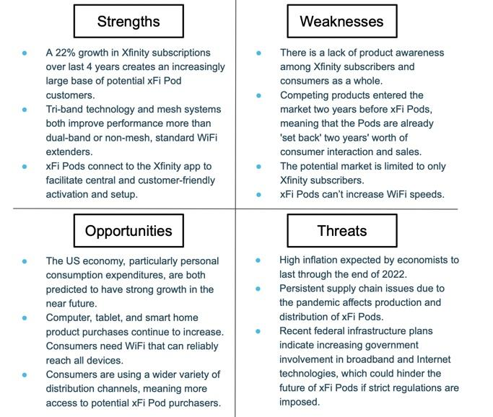

# Competitive Analysis of the Marketplace

## Amazon Eero

Amazon has an overall market capitalization of about $1.7 trillion (“Mergent Online - Company Detail: Amazon.com Inc.,” 2020). It has a 3.54% market share in the Electrical Retail Websites sector, comprising “computing, home appliances, small appliances, smart tech and phones, and sound and vision” (Pi Datametrics, 2021). The company’s revenue in 2020 totaled $386.06B (“Amazon.com, Inc.”, 2021), with technology and content accounting for 11.1% of Amazon’s total sales (“Amazon.com, Inc. Form 10-K,” 2021), and net income was $21.33B (“Amazon.com, Inc. Form 10-K,” 2021). Products and services from Eero, which was valued at about $251M in 2016 before being acquired by Amazon in 2019 (Armental, 2019), generated a revenue of $5.9M in 2020 (“Amazon.com, Inc. Form 10-K,” 2021).

As the leading e-commerce retailer, Amazon has several strengths to differentiate itself from its competitors, specifically Comcast. First, the latest version of the Eero product, the Eero Pro 6, is a mesh Wi-Fi network in which there are multiple access points throughout the home and devices automatically connect to the closest access point while seamlessly staying on the same network. This allows consumers to “customize the system, adding additional devices that plug into outlets, based on the size -- and shape -- of the house” (Armental, 2019). The very flexible nature of this technology would be attractive to consumers who have had previous issues with Wi-Fi networks due to unchangeable factors such as the architecture of their house.

Amazon expects an increase in spending in its technology and content areas and plans to hire more “computer scientists, designers, software and hardware engineers, and merchandising employees” (“Amazon.com, Inc. Form 10-K,” 2021). The Research & Development goal to “invest efficiently in several areas of technology and content” and the “expansion of new and existing product categories and service offerings” is a strength to Amazon’s Eero because the product design and functionality will likely improve (“Amazon.com, Inc. Form 10-K,” 2021).

Amazon’s Prime membership program sets it apart by enabling a quick and simple checkout process, as well as faster shipping and sometimes discounted prices. Because of these benefits, a Feedvisor survey shows that Amazon has high brand loyalty, as 48% of all Amazon Prime members buy products online at least once a week and 74% shop online at least every few weeks (Masters, 2019).

However, Amazon also has a few weaknesses in regards to its Eero Pro 6. Amazon has become the go-to online retailer for most shoppers, yet many consumers utilize the company’s website to search for nationwide brands rather than Amazon’s private label brands. In fact, a Feedvisor survey found that 74% of consumers attributed brand name as an important factor when selecting a product, and 59% of Amazon’s high-volume daily shoppers noted that brand name was a very important factor when selecting a product (Masters, 2019). Because Amazon has yet to establish itself as a high-quality manufacturer, many still perceive Amazon as a global retailer and distributor, which may cause consumers to overlook the Eero Pro 6 and opt for a more well-known brand for consumer electronic goods and services such as Comcast.

Since Amazon is mainly positioned as a distributor it depends heavily on other firms for supplies and manufacturing. Furthermore, it does not have any sort of permanent arrangements with most of its suppliers or a way to “guarantee availability of merchandise, content, components, or services, particular payment terms, or the extension of credit limits” (“Amazon.com, Inc. Form 10-K,” 2021). This leaves the company vulnerable to unwanted effects of the actions of others in its supply chain.

Listed at $449, the Eero Pro 6 is only sold as a pack of three Pods compared to the one- or two-packs for Comcast’s xFi Pods (“Amazon.com,” 2021). Amazon’s product requires more Pods to be installed at a higher overall price, whereas Comcast has the potential to be almost three times cheaper if a consumer only requires one Pod to enhance Wi-Fi coverage.

Current users of Amazon Eero products are consumers who most likely have larger homes with many devices that require fast internet speeds. This assumption comes from the fact that the Eero mesh system can connect up to 75 devices throughout the home, covering up to 6,000 square feet and delivering internet speeds up to one gigabit (“Amazon eero Pro 6 tri-band mesh Wi-Fi 6 system with built-in Zigbee smart home hub (3-pack),” 2021). These features allow greater connectivity, coverage, and speeds within the home to provide consumers with an integrated mesh system. It can also connect to and be controlled by Amazon Alexa devices (“Amazon eero Pro 6 tri-band mesh Wi-Fi 6 system with built-in Zigbee smart home hub (3-pack),” 2021). If consumers already own an Alexa device, they may be more inclined to purchase the Eero Pro 6 because of its seamless compatibility and ease of use. Because of its compatibility with Alexa, current consumers of the Eero are likely to be younger and more technologically adept. Since the Eero Pro 6 can cover up to 2,000 square feet (“Amazon eero Pro 6 tri-band mesh Wi-Fi 6 system with built-in Zigbee smart home hub (3-pack),” 2021), it is likely that the product’s consumers are wealthier to accomodate a larger living space.

## Google Nest Wi-Fi Router

Alphabet Inc., the parent company of Google, has a market capitalization of about $864B (“Mergent Online - Company Detail : Alphabet Inc.,” 2021). Alphabet’s revenues for the fiscal year-ended 2020 totaled $182B, with Google’s revenues accounting for $2.1B (“Alphabet Inc.,” 2021). Google Nest comprises 26% of the smart home market (“Smart home: Google Nest in the United States,” 2021) and its total revenues for fiscal year-ended 2020 was $37M (“Alphabet Inc., 2021). Alphabet’s 2020 net income totaled $40.269B ("Mergent Online - Annual Reports : Alphabet Inc.," 2021).

Google Nest’s strengths lie in its name referring to more than just a Wi-Fi mesh extender, but rather a comprehensive smart home product line. This helped give it the largest share in the smart home market (“Smart home: Google Nest in the United States,” 2021). Google Nest offers a broad range of products that are compatible with each other, including its mesh Wi-Fi system, which provides seamless interaction among devices and an easy user experience.

Using a Nest Wi-Fi router along with at least one Wi-Fi point, the Nest Wi-Fi system can handle up to 200 connected devices and is fast enough to stream multiple 4K videos simultaneously (“Nest Wifi,” 2021). Each point is also a smart speaker that can play music and answer questions by using Google Assistant technology (“Nest Wifi,” 2021).

Google Nest’s weaknesses stem from its inexperience in selling consumer goods. Outside of its search engine and advertising business, Google has relatively little operating or product sales experience compared to its competitors like Amazon ("Mergent Online - Annual Reports : Alphabet Inc.," 2021). However, the portion of revenues derived from sources other than advertising is increasing, in part due to the increase of hardware products, including the Google Nest ("Mergent Online - Annual Reports : Alphabet Inc.," 2021). Although Google is beginning to gain experience and obtain a greater foothold in the smart home market, the Google Nest product line marks the company’s first endeavor into offering direct-to-consumer products compared to Comcast who has been consumer-facing for decades.

Although Google has a global brand name recognition, the company faces criticism largely due to its use of consumer data. With large amounts of data being collected by Google Nest products, many consumers are concerned about their data privacy. This may hinder consumers from purchasing Google Nest products and may negatively impact the brand name. Damage to the Google Nest brand also arose due to recent lawsuits by Sonos regarding patent infringement on some Google Nest products (Mickle, 2021).

Because Google Nest’s Wi-Fi system can easily connect to and integrate with other Google smart devices, the product’s consumers are likely ones who already have other Google Nest devices and are familiar with the brand. They likely enjoy the Google Assistant technology embedded in each point that plays music, answers questions, and controls other smart devices. Google Nest’s broad product line of smart home devices allows consumers to create seamless connections between their devices throughout their homes. Because of the capability to stream videos simultaneously, current consumers may also have multiple children who watch movies using the internet.

## NETGEAR Orbi

NETGEAR has a company-wide market capitalization of $914M (“Mergent Online - Company Detail : Netgear Inc.,” 2021). For the fiscal year ending in 2020, it had total revenues of about $1.26B and a net income of about $58M (“Mergent Online - Company Detail : Netgear Inc.,” 2021). The Connected Home segment of NETGEAR, which includes its Orbi mesh extender, accumulated net revenue of just over $1B and accounted for 80.3% of the company’s total revenue (“NETGEAR Inc. Form 10-K,” 2021).

The recent pandemic drove the company’s sales and profitability, specifically the Connected Home Segment, whose net revenue grew by 41.6% in comparison to the previous fiscal year (“NETGEAR Inc. Form 10-K,” 2021). NETGEAR saw a 48.8% year-over-year increase in revenue from the Connected Home segment in the fiscal year 2020 (“NETGEAR Inc. Form 10-K,” 2021). This increase in revenue sparked by COVID-19 may establish NETGEAR as a more popular option for Wi-Fi mesh extenders.

NETGEAR partnered with Bitdefender to offer NETGEAR Armor, an optional add-on subscription service that protects consumers’ home Wi-Fi network and all devices connected to it (“NETGEAR Armor - Resources: Protect Home Networks,” 2021). For $99.99 a year, consumers are able to reap the benefits of cybersecurity coverage, smart home vulnerability scans, anti-theft protection, and much more (“NETGEAR Armor - Resources: Protect Home Networks,” 2021). This additional service differentiates NETGEAR from its competitors by positioning itself as caring for consumers’ Wi-Fi and internet safety.

However, one of NETGEAR’s main distribution channels relies on Amazon for the sale of its mesh extenders (“NETGEAR Inc. Form 10-K,” 2021). This is a weakness since Amazon Eero is a competitor of the Orbi. Because of this, NETGEAR could be vulnerable to biased algorithms in Amazon’s search engine results, which could lead to Amazon’s products being prioritized over those of NETGEAR.

Current Orbi consumers likely highly value their internet safety because of the numerous cybersecurity protections provided by NETGEAR Armor. In fact, they value their cybersecurity so much that they are willing to pay an annual subscription of $99.99 to ensure their protection. Because of their willingness to pay a price premium, these consumers are most likely to be wealthier than the average consumer. Because of their concern about privacy and security, these consumers may be older than those who use the Amazon Eero or the Google Nest Wi-Fi system.

## TP-Link Deco

Because TP-Link is a private company, its financial statements are not readily available. However, the company’s total revenues are estimated to be about $94.22M (“TP-Link USA Corporation,” 2021).

Unlike NETGEAR or Amazon who require a paid subscription for cybersecurity, TP-Link differentiates itself by including the service in every purchase of its Deco products. In fact, TP-Link offers hardware security, real-time antivirus protection, advanced encryption, and content filtering (“Deco,” 2021). TP-Link also sells a Deco model that is compatible with various Internet of Things smart devices such as smart bulbs and door locks and can control them via a mobile app (“Deco M9 Plus Smart Home Device Compatible List,” 2021).

However, one of the main weaknesses of TP-Link is its small size in comparison to its competitors. Although the company’s financial reports are not disclosed publicly, TP-Link almost certainly has a much smaller advertising budget than its competitors given the vast differences in revenues. Because of this, TP-Link may also have difficulty exposing its brand to new consumers.

Current consumers of TP-Link Deco products are likely those who are a combination of Google Nest users and Orbi users. This is because the TP-Link Deco satisfies both the cybersecurity needs and the Internet of Things aspects of the other products. These consumers care enough about their internet security that they choose a product that protects them from cyber threats, but they also are not as wealthy as those who purchase NETGEAR’s Orbi because TP-Link’s consumers do not pay an additional premium. Some TP-Link consumers also appear to be more technologically advanced than other consumers because they may choose to purchase the Deco model that has compatibility with other smart devices via the Internet of Things.

## Linksys Dual-Band Wi-Fi Range Extender

Foxconn Technology Co., the owner of Linksys, has a market capitalization of $98.023B (Foxconn, 2021). Foxconn is the supplier of Apple and relies on Apple for about half of its total revenue (Wang, 2021). In 2020, the company had a total revenue of $192.689B (Wang, 2021). For fiscal year end 2020, the company experienced a net profit of $3.56B (Wall Street Journal, 2021). Linksys offers an array of Wi-Fi extenders, but its most popular is the Linksys Dual-Band Wi-Fi 6 Range Extender because of its range and ease of use.

Of all of the Wi-Fi extenders mentioned, the Linksys Dual-Band Wi-Fi Range Extender has the greatest range as it can extend coverage by up to 2,000 square feet (Linksys, 2021). This is about 400-500 square feet of coverage greater than Google Nest and xFi Pods. Because of this, the Linksys Wi-Fi Extender may be seen as more suitable for people with bigger homes who want to maximize the range of their Wi-Fi.

An additional advantage of the Linksys Dual-Band Wi-Fi Range Extender is that it is compatible with any router (Linksys, 2021). Unlike xFi Pods, which require users to subscribe to Xfinity, the Linksys Wi-Fi extender is compatible with all routers, including those from service providers and does not require users to modify their router settings (Linksys, 2021).

The Linksys Dual-Band Wi-Fi Range Extender offers an easy setup with a Push-Button connection to sync the extender with the consumer’s router (Linksys, 2021). The easy set up is appealing to those who are less technologically able, namely those in the 65 and older age range. Linksys extender’s ease of use and setup will attract those in that demographic.

However, the Linksys Dual-Band Wi-Fi Range Extender is only dual-band, meaning that devices will not get a dedicated backhaul, but rather share this signal with your router (Linksys, 2021). This becomes a problem when consumers are trying to send large amounts of data.

# Perceptual Map

We chose price and range as axes of comparison as these are two major factors that affect consumer decision making. Consumers will weigh the benefits of the extended range to the price of the extender and decide if the added range is worth the price. Some consumers may be willing to pay more for a larger range if they have a larger house, while other consumers who only need a smaller range extension will choose the lower priced, lower range option. Among major competitors, the price range and amount of range extension varies greatly. The highest priced Wi-Fi extender is the NETGEAR Orbi at $249. The NETGEAR Orbi is tied with the Linksys Dual-Band Wi-Fi Range Extender for the largest range extension at 2,000 square feet. The high range could be a potential justification for the high price, but the Linksys extender has the same range extension for a lower price. The Linksys Dual-Band Wi-Fi Range Extender is in the middle of the pack for price at $99. The Linksys extender is a more attractive option in consumers' minds compared to the NETGEAR Orbi because it offers the same range extension for a lower price. The second highest priced Wi-Fi extender is the Google Nest Wi-Fi Extender at $149, which also has the second highest range at 1,600 square feet. Amazon’s Eero and Xfinity xFi Pods offer the same range extension at 1,500 square feet. However, the Amazon Eero is significantly less expensive, costing $69 compared to the xFi Pod’s $119 price tag. This makes the Amazon Eero much more appealing in consumers' minds as it offers the same benefit for a much lower price. The Google Nest, Amazon Eero, and xFi Pods all offer a middle range extension, but because of its significantly lower price, the Amazon Eero is the most appealing to consumers. The xFi Pods are competing in a crowded sector of Wi-Fi extenders. If the xFi Pods want to differentiate from the Google Nest and Amazon Eero, the range needs to increase while leaving the price the same, or the price needs to go down while leaving the range the same. By pursuing one of these options, the xFi Pods will have a better price to range ratio, making it significantly more appealing to consumers. The lowest price of all the extenders is the TP-Link Deco which costs $49. The TP-Link Deco also offers the lowest range extension at 1,200 feet, making it the ideal choice for people who only want a smaller range extension for a low price. 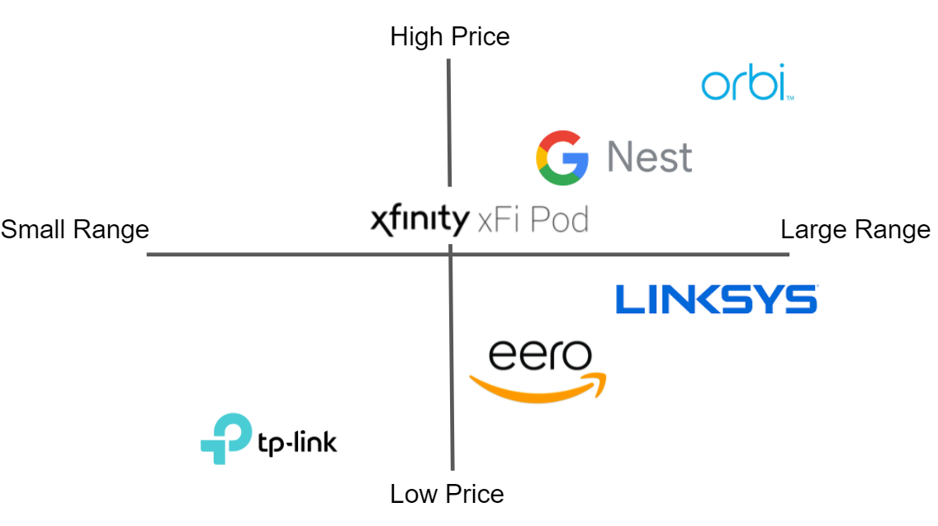

Key Insights (Lilah)

To differentiate the xFi Pods from competitors in our target market, we will demonstrate how the xFi Pods are consumers’ most dependable and affordable product that adds the most utility to consumers’ data. Through integrating augmented reality (AR) and data analytics into the user set-up experience, xFi Pods solidify themselves as the most appealing and practical Wi-Fi mesh extender on the market. Additionally, customers are able to best leverage the xFi Pods’ boosting capabilities in an unparalleled and interactive way through the Xfinity app. To exemplify all the benefits xFi Pods have to offer to consumers, we are communicating to customers that they need xFi Pods to “Bring your dead zones back to life.”

To support our unique selling proposition and central communications theme, we knew to place an emphasis on xFi Pods being the best solution to fix dead zones in people’s homes. We found that there is a strong need to remedy dead zones as 72% of respondents either somewhat or strongly agreed that they experience Wi-Fi dead zones in their home (xFi Xperts Primary Research Survey, 2021). Additionally, 83% of respondents either somewhat or strongly agreed that they would consider using a Wi-Fi extender (xFi Xperts Primary Research Survey, 2021). These primary sources highlight that having steady, reliable internet is very important to consumers, which creates a need for a great Wi-Fi extender, like xFi Pods, to ensure consistent connectivity throughout one’s home.

Marketing Strategy (Sarah)

# Segmentation Strategy and Segment Definition

## Key Segment

Our target audience will be current Comcast subscribers between the ages of 30 and 55 with children and who live in suburban areas of the Mid-Atlantic region with a secondary focus on suburbs surrounding major cities in regions such as the South-Atlantic and Northeast, with an emphasis on those who live in multi-level homes. The Mid-Atlantic has the highest concentration of Xfinity Wi-Fi users as well as the highest average home square footage with a mean of 2,500 square feet in newly built homes (NAHB Estimates, 2019). With this, we also decided to focus on Northeast and South-Atlantic metropolitan areas since their average home square footage ranges from 2,100 to 2,300 square feet, respectively (NAHB Estimates, 2019). Since 1960, the percentage of dual-income households with children under the age of 18 has been increasing (U.S. Bureau of Labor Statistics, 2020). This trend indicates that the purchasing power and growth rate of our target market will be on the rise, allowing us to further capitalize on them now and indefinitely.

We estimate that the size of this segment is approximately 5,251,124 people. To arrive at this number, we first found the number of people between the ages of 30-55 in the regions of New England, the Mid-Atlantic, and the South Atlantic as designated by the US Census, which turned out to be 39,070,862 (US Census Bureau, 2019). Then, this number was filtered down by looking at the percentage of people earning more than $100,000 per year, which was 33.6%, this means that there are approximately 13,127,810 people in our target age-range who earn more than $100,000 per year (US Census Bureau, 2021). Finally, we reached our final estimate by filtering it down further to only include the estimated number of Comcast subscribers, which we used 40% as that was stated to be its market penetration in the internet segment, so we reach a final estimate of 5,251,124 people in our target market (Leichtman Research Group, 2021).

## Justification for Less Appealing Segments

Although there were several additional segments that we could have chosen to target, we determined that the one previously described was the most suitable for our campaign. Rather than targeting children, we are focusing on adult Comcast subscribers because they are the ones likely to be making the purchase. We deprioritized teenagers and young adults because the age group under 30 makes up nearly half of the U.S. population of renters (NMHC, 2020). Additionally, the majority of those between the ages of 22 and 30 who are homeowners live in a residence that is less than 2,000 square feet in size (Statista Research Department, 2020). These apartments and smaller size houses are less likely to be experiencing a need for Wi-Fi extenders because one of the main factors contributing to dead zones is the size and layout of a home.

## Persona For Our Segment

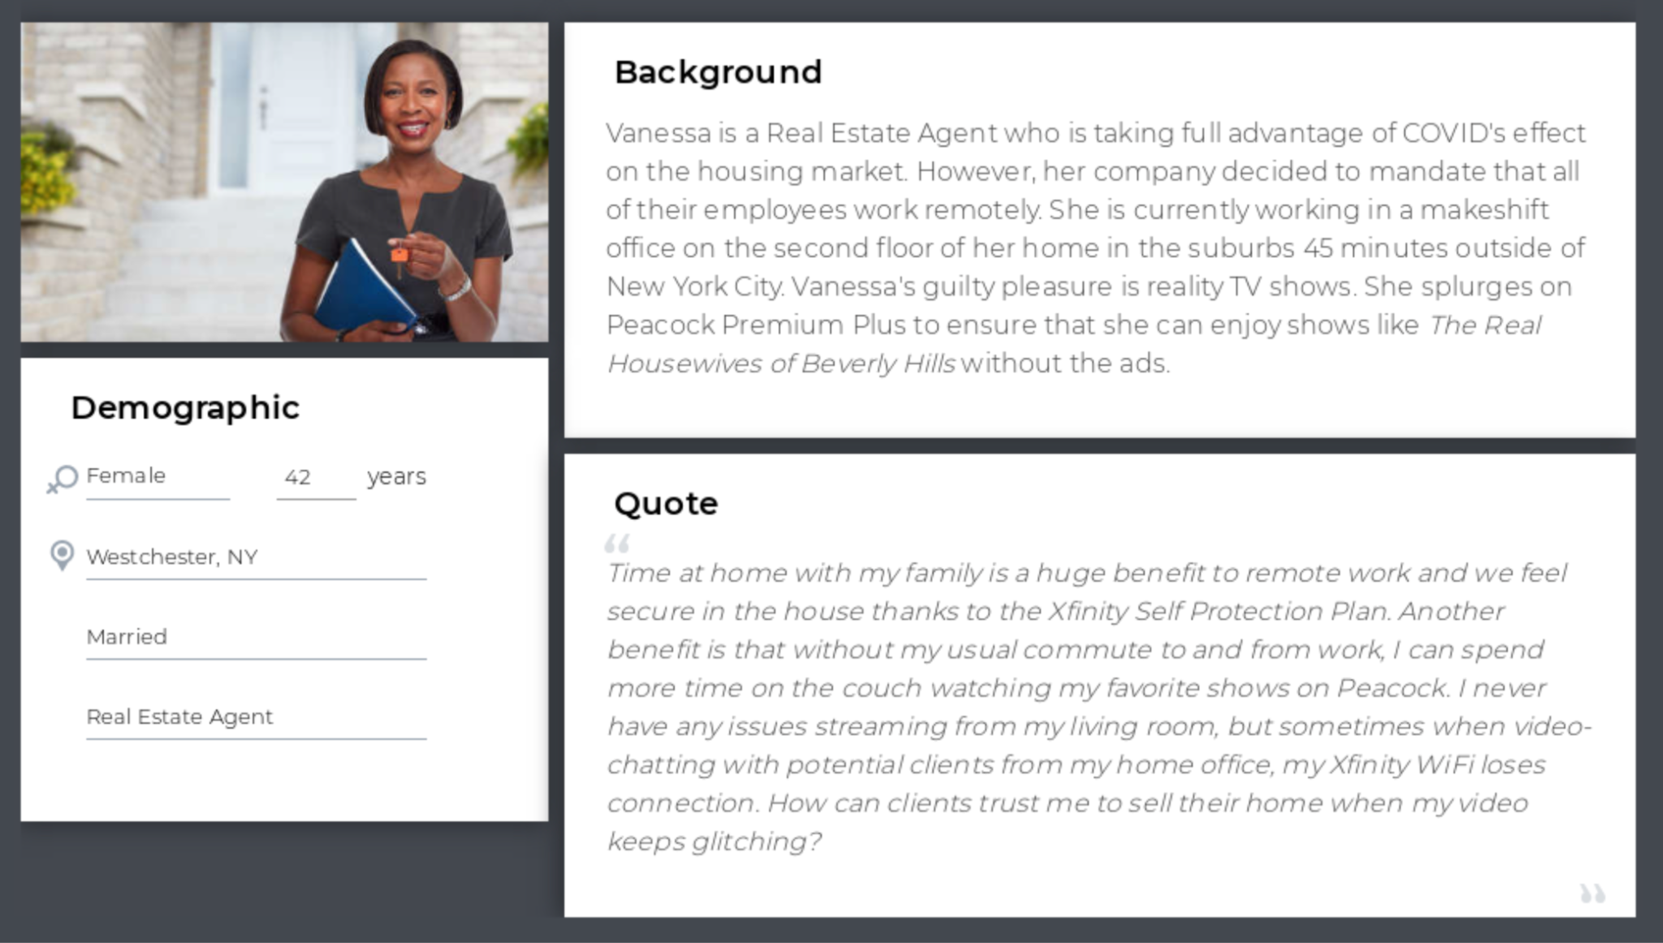

## Current Segment Engagement

Residential broadband services comprise the largest single category within the Internet Service Provision industry, consisting of 31% of industry revenue and growing as a percentage of total industry revenue over the past five years (Moses, 2021). There is a clear, long-term demand for residential broadband services, making this a target segment with a significant likelihood of favorable revenues. Our market size is considerably large since 69% of respondents either agreed or somewhat agreed that they experience Wi-Fi dead zones in their house; therefore, they would benefit from the consistent Wi-Fi connectivity provided by the installation of xFi Pods (xFi Xperts Primary Research Survey, 2021). To differentiate the product by emphasizing our commitment to providing the best user experience, we are offering services within the Xfinity mobile application that facilitate the installation process. A frequently asked question regarding the xFi Pods is, “How do I install and activate my Pods?” (Xfinity, 2021). Since 67% of our survey respondents said they would be willing to pay a price premium for products from a company that collects and uses personal data responsibly (xFi Xperts Primary Research Survey, 2021), another point of emphasis would be Comcast’s responsible use of data to improve customers’ performance.

# Targeting Strategy

The TV, streaming service, and radio advertisements that are published at the start of our promotional campaign will be undifferentiated. This phase will be a universal message creating awareness of the xFi Pods. Informing consumers of the product and its functionality is something that does not need to be tailored to each potential customer. Therefore, the marketing mix will remain the same for the mass market.

Our display advertisements which will appear across platforms such as technology websites, innovation magazines, and product review sites are going to be differentiated. The audience of these advertisements will be customers who are invested in the product category. Therefore, the marketing mix will be altered to emphasize the more technical aspects of the xFi Pods.

The advertisements that we will run across the Xfinity website, Xfinity app, and emails to existing customers will be much more concentrated. Using a niche marketing strategy here will allow us to capitalize on the Xfinity customers who have not yet purchased or considered xFi Pods. We will emphasize the convenience of using one provider for all of the Internet services in a household. This specific segment and type of customer is extremely valuable.

Product (Nick, Lilah)

Put simply, xFi Pods are Wi-Fi mesh extenders that are designed to improve users’ Wi-Fi connectivity throughout their homes and to eliminate Wi-Fi dead zones (Xfinity, n.d.). Released in 2020, this is the second generation of the product and unlike other Wi-Fi mesh extenders, they are proprietary to Xfinity home network setups. In other words, only users with Xfinity as their ISP and who have the Xfinity Gateway (Xfinity’s version of an all in one router, modem, etc.) are able to use xFi Pods with their home networks (Takiff, 2020). As a result of this propriety, most of the complementary goods that are most frequently bought with xFi Pods are other Xfinity products and services. For example, xFi Pods are mailed at no extra cost to customers who subscribe to xFi Complete, the highest level internet experience that Xfinity offers, if dead zones are detected in their homes (Xfinity Chat Agent, 2021).

Though Comcast has addressed many of Xfinity users’ needs through updates on its app, we firmly believe that we can enhance the consumer experience and differentiate ourselves from competitors, whose products are largely undifferentiated compared to xFi Pods, by implementing an update that utilizes AR. To gain a visual sense of where in the house the Wi-Fi is running inefficiently, we are proposing that Comcast create a feature that allows users to use their camera to scan their home, visualizing a heat map of Wi-Fi connectivity throughout their home. The app will allow users to pinpoint where the Wi-Fi is working ineffectively in their homes and will suggest the best locations within the home to place an xFi Pod. Additionally, we will configure the app so that it will recognize where the Wi-Fi router is located in one’s home and utilize the camera to decipher what obstacles may possibly block xFi Pods from working effectively, like a couch.

Price (Lilah, Samantha)

Considering that xFi Pods are late entering into the market, our objective is to pursue status-quo pricing. This passive pricing policy will allow Comcast to maintain existing prices or meet a competitor’s prices. Currently, xFi Pods are priced at $119 for one Pod or $199 for a pack of two. Amazon Eero, one of the cheaper competitors, sells one Pod at the cost of $69, and also has Alexa compatibility, which is an augmented layer that we do not have. Although the xFi Pods have a higher price compared with the Amazon Eero, Comcast makes up for it through it’s distribution as it is an end-to-end company. However, it may be necessary to lower the price of the product to gain more customers. Since only 52% of respondents were at least somewhat familiar with xFi Pods whereas 66% and 73% were aware of competing products from Amazon and Google, we need to lower our prices in order to gain recognition from Xfinity Wi-Fi users (xFi Xperts Primary Research Survey, 2021).

However, we must be sure that our need to lower prices from a competitive point of view does not undermine our goal of increasing revenue. One way to balance these two aspects is by introducing a buy now, pay later (BNPL) feature, either internal to Comcast or through a third-party service such as Affirm, Afterpay, or Klarna. BNPL breaks up the cost of purchase into equal payments over a relatively short amount of time, typically interest-free, and with no hidden fees (Reagan, 2021). Although the total amount paid remains the same, the concept of an extended interest-free payment schedule has proven to be very enticing to consumers, as it helps outweigh reluctance to pay a high up-front cost (Pyke, 2021). It also leads to a 20 to 30% increase in conversion rates (Reagan, 2021). Online retailer Rue21 found that customers are 6% more likely to make a purchase if they use BNPL (Reagan, 2021), showing that this feature is both effective for retailers and attractive to customers. Furthermore, Macy’s reported that its sales to new customers in particular increased when they started using a BNPL service (Reagan, 2021). This is notable for our purposes because, in general, our target market has not previously bought an xFi Pod before. The availability of this flexible pricing option contributes to the overall theme of xFi Pods being the most convenient option. It aligns with the mission of differentiating the product based on personability and ease by providing consumers with extended periods to purchase.

Distribution (Max, Lilah)

According to the xFi Pods frequently asked questions page, Pods can either be purchased at an Xfinity store or ordered online from the Xfinity website (Xfinity, 2021). Xfinity does not officially partner with any intermediaries to sell the xFi Pods. Currently, there are 558 Xfinity stores located throughout the US, each of which has xFi Pods on site (Xfinity, n.d.).

The current method of distribution is insufficient to meet the needs of the customer. We believe that a good way to expand the opportunities for customers to purchase xFi Pods would be to have technicians keep them on their trucks, that way, if they are at a house experiencing problems with their Wi-Fi and it turns out they have dead zones, they can sell the product to them then and there. We want to improve the convenience of the transaction for the customer by providing the technicians with it so they can immediately solve their need. It is not necessary to put them into major retail outlets because the Pods only work for Xfinity customers, and Xfinity is not a national company, so it would not make sense to offer the product in national chains.

Branding Strategy (Cara)

# Specific Campaign Objectives

While the fundamental goal of our campaign is to increase sales, and ultimately revenue, of xFi Pods among current Xfinity customers, there are several goals that we hope to achieve prior to reaching the end goal.

A main objective of the campaign is to focus on spreading awareness about Comcast’s Wi-Fi mesh extender product. Because the first Wi-Fi extender was introduced in 2016 by Amazon (Comcast NBCUniversal, 2021), the general product category is relatively new. Many consumers are unaware of the functions and benefits of using a Wi-Fi mesh extender. Among those who are aware of the general product, many are uninformed about Comcast’s specific product. In fact, our primary research indicates that while 52% of respondents were at least somewhat familiar with xFi Pods, 66% and 73% were aware of competing products from Amazon and Google, respectively (xFi Xperts Primary Research Survey, 2021). With awareness levels of xFi Pods lagging behind those of competitors, our campaign aims to increase product awareness to 75% of all consumers by the end of 2022, as well as decrease the number of unaware Comcast users by from 48% to 25% within the same time frame.

To increase product awareness, a complementary campaign objective is to inform the target audience about the improved Xfinity app and to encourage them to use the app more frequently. The interactive app experience will use AR capabilities to visually represent the dead zones in a consumer’s home and to simulate the enhancements made by xFi Pods. By educating consumers about the app’s expanded capabilities, our campaign will communicate the benefits of purchasing an xFi Pod by having an engaging user experience in the app. Increasing awareness about both xFi Pods and the new Xfinity app will spark interest among the target audience to download and use the app. Higher engagement with the Xfinity app will drive interest in xFi Pods among consumers.

Increased interest levels in xFi Pods will stimulate desire among consumers, which should motivate them to purchase the product. Although the end goal is to increase sales and revenue of xFi Pods, it is simply a function of raising product awareness and interest in xFi Pods and the enhanced Xfinity app. Embedded within the end goal is to promote and foster a sense of brand loyalty among consumers by positioning Comcast as an innovative company that cares about its consumers.

# Unique Selling Proposition

The xFi Pods serve as a reliable and affordable product that differentiates itself by adding the most utility to consumers’ data. They are the most engaging and useful choice for Wi-Fi mesh extenders by integrating augmented reality (AR) and data analytics into the user set-up experience. This allows the customer to best leverage the boosting capabilities of the xFi Pods in a unique and interactive way via the Xfinity app.

# Reasons to Believe

* Recent academic research has shown that AR usage has heightened user satisfaction, increasing consumers’ willingness to purchase products and resulting in positive effects on brand awareness, association, and loyalty (Berman & Pollack, 2021).
* 73% of consumers who used AR in the purchase process reported being satisfied or very satisfied by the product that they eventually went on to purchase (Baird, 2021).
* The use of augmented reality in apps has proven to be successful for other companies. IKEA introduced an AR feature in its app which led to an increased spike in Google searches and moved to #2 on the App Store among free AR apps (Williams, 2018).
* E-commerce company Shop-ify reported a 65% increase in sales of its Rebecca Minkoff accessory line when consumers used AR to view its products (Berman & Pollack, 2021).

# Positioning Statement

Comcast’s xFi Pods are perfect for current Xfinity subscribers between the ages of 30 and 55 with children who want to enhance and personalize the internet coverage within their home through an immersive user experience. Unlike Google or Amazon, Comcast will use your data to improve your life, not complicate it.

# Tone and Voice for the Campaign

Because our primary research indicates that 48% of current Comcast users have no familiarity at all with xFi Pods compared to awareness levels of 66% and 73% with Amazon’s and Google’s respective products (xFi Xperts Primary Research Survey, 2021), the overall appeal of the campaign will be informative. With the objective of raising product awareness amongst current Xfinity users in mind, our campaign seeks to educate the target audience about the augmented reality experience in the Xfinity app, which in turn will promote interest in xFi Pods. By explaining the benefits of using the unique AR app to identify Wi-Fi dead zones, the rational appeal of the campaign will ultimately drive the sales of xFi Pods.

Because we are targeting younger to middle-aged parents, the tone of the campaign will convey familial values. The campaign’s tone will be light-hearted, upbeat, and welcoming to stimulate customers’ curiosity in the product and engaging app experience.

# Central Communications Theme

Bring your dead zones back to life.

# Big Idea

The campaign’s overall theme is one rooted in innovation and enhancement. With augmented reality’s rise in daily life, the campaign demonstrates that Comcast is an adaptive company that is not afraid to change as the business landscape evolves. In fact, implementing cutting-edge technology such as AR positions Comcast as a leader and a pioneer in the industry. With a focus on supporting the needs and interests of consumers, the campaign is unified by its priority placed on customer interaction and engagement. It conveys the message that not only does Comcast seek to simplify the lives of its consumers, but it also strives to improve their experience and overall satisfaction with the company.

Promotional Schedule (Max, Samantha, Nick, Cara)

# Promotional Time Period Length and Budget

With a $20M budget, our campaign will run from January 1st, 2022 through January 1st, 2023, making the campaign one year long as determined by Comcast (Comcast NBCUniversal, 2021). As noted by Comcast during our meeting on November 1, 2021, the company’s peak season for internet usage occurs from June through July and November through December, and it experiences the most new user sign-ups during Q3, which lasts from July through September. In fact, according to the company’s published quarterly Earnings Reports, it experienced a net addition of 617,000 broadband residential customers in Q3 of 2020, more than any other quarter that year (Comcast Corporation, 2021). Additionally, Comcast experienced $5.8B in total revenue in Q3 of 2021, which was more revenue from Broadband Cable Communications than any other quarter of 2021 (Comcast Corporation, 2021).

With this in mind, our campaign will have three phases, one focused on building awareness about the product with the following two aimed at encouraging sales of xFi Pods. We will start our marketing campaign in the months leading up to June to establish a foundation of awareness and to allow sufficient time for customers to gain interest in xFi Pods prior to the first peak of consumption and sign-up periods. After this first spike in consumption and new user sign-ups during Phase Two, the final phase will focus on building awareness about the product, specifically among those who may not have been reached in the launch wave, as well as capitalizing on another peak time period, which Comcast noted occurs during the winter months, as seen by its Advertising, Marketing, and Promotions expenses in Q4 2020, which amounted to $1.042B, more than any other quarter that year for Cable Communications (Comcast Corporation, 2020). This phase will wrap up the year-long campaign by further enticing people to purchase xFi Pods during this second peak period.

# Media Schedule

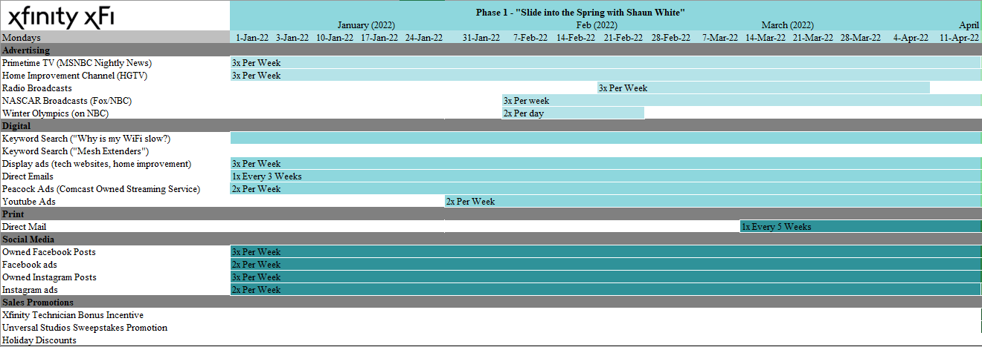

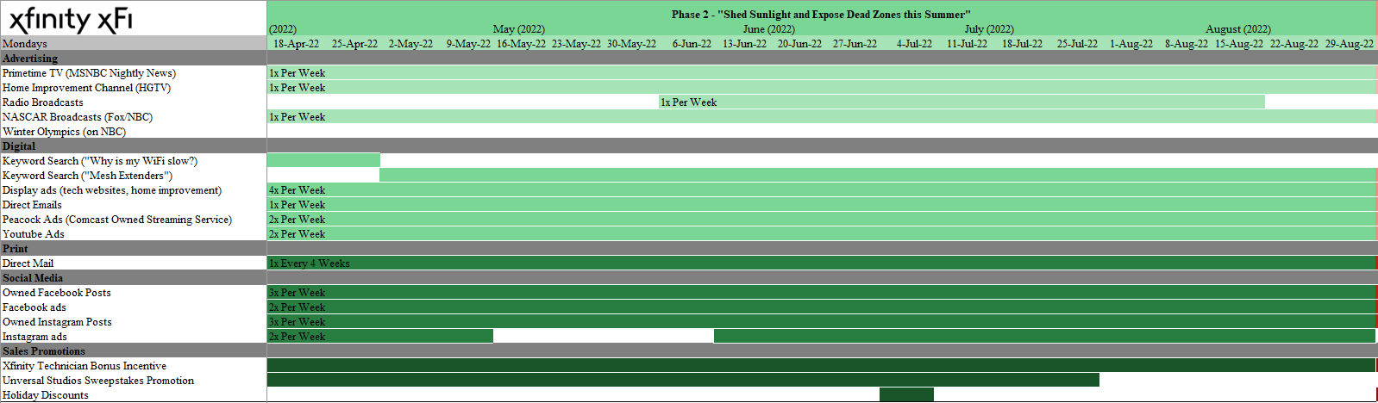

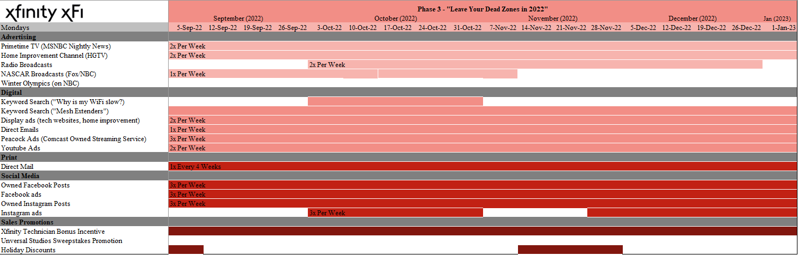

# Top-Line Budget

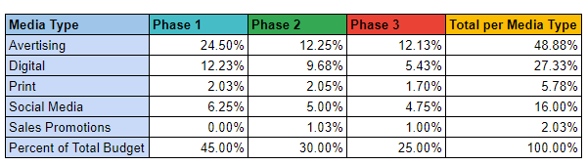

Looking at the breakdown of the budget per phase, a majority of our budget was spent in Phase One (45%). This is because the awareness of the functions of a mesh extender, as well as the brand awareness for Xfinity’s product is relatively low, at 59%, when compared with Amazon and Google’s 73% and 66% respective product awareness rates (xFi Xperts Primary Research Survey, 2021). By spending more money in Phase One compared to other phases, we will be able to increase the awareness of the product and alert people of a need they might not have known they had (dead zones), as well as xFi Pods as a potential solution.

In Phase Two, the goal is to begin creating desire and action for the product that corresponds with the peak usage season noted by Comcast in our November 1st meeting. To do this, we will spend a large part of the remaining budget (30% of the total) on marketing activities such as sales promotions, personal selling, among others. Even though the focus primarily will be on increasing sales, we will still be involved in some advertising aimed at raising awareness among those who might not have been exposed to the advertisements in Phase One.

Phase Three’s goals are somewhat similar to those of Phase Two. However, in the month of October, the focus is more on awareness than on selling, which pivots at the end of October as we enter the Holiday season. Once the phase reaches mid-November and December, there will once again be a shift towards a more sales-focused approach. The remaining 25% of the total marketing budget will be allocated to this phase in order to both retarget any customers who were previously missed, as well as move towards the sales approach.

Breaking the budget down by Media type, a large portion of the budget (48.88%) will be spent on traditional advertising such as TV and Radio. We did this because we feel that the xFi Pods are a relatively simple product and their function can be communicated effectively over traditional mediums to a wider audience.

The next highest budgetary expense was on digital advertising, with 27.33% of the budget being spent on it. Digital advertising is able to generate a considerable amount of impressions for the money that is spent on it. Though it may not be as effective as other mediums at generating action, it is still a useful method to generate awareness of the brand and product. Social media ads only made up 16.00% as they are another less costly method to reach a vast audience. Similar to digital advertising, the social media campaigns will first act to raise awareness for the product then to later promote desire and action.

The last significant expenditure in the marketing campaign is on print advertising, more specifically, direct mail. The proportion of the total budget spent on this is 5.78%. Direct mail is more expensive than the other mediums, but it also has a higher action rate than the other mediums because people like the tangibility of having the advertisement in their hand, there is no opportunity for them to throw it away. The last expenditure, 2.03% of the total, will be spent on sales promotions. The proportion is minor as we will only be sending one family for a week to a Comcast-owned resort, and the advertising cost for this event is factored into the traditional and digital advertising budgets.

# Wave-by-Wave Budget and Objectives

As mentioned before, the primary objective of Phase One will be to raise awareness for both Wi-Fi mesh extenders and the Xfinity brand since it lags behind competitors like Google and Amazon in recognition (xFi Xperts Primary Research Survey, 2021). To do this, we will keep a significant presence on traditional advertising mediums such as TV and radio. With digital ads, the focus of the keyword search advertisements initially will be more focused on helping people identify problems they have with their Wi-Fi to build awareness for the xFi Pods as a possible solution to it. Later on in the phase, we will shift to focusing on promoting xFi Pods when people are searching for the best Wi-Fi extenders. There will also be a focus on display ads and YouTube ads throughout the phase. Towards the end of the phase, we will begin the direct mail campaign to begin stimulating more interest, desire, and action for the next phase. Regarding the social media ads, a presence will be maintained on Facebook and Instagram throughout the year, which will not significantly change between the phases. Finally, unique to Phase One is the Winter Olympic promotions and the hiring of Shaun White in several commercials, which will serve to complement the digital and traditional advertising campaigns in this phase by associating the product and brand with someone who is widely known and liked by people in our target demographic (YouGov, n.d*.*).

Transitioning to Phase Two, the goal transitions from raising awareness to pushing the product during the peak usage season. The presence on traditional advertising mediums will remain similar to the previous wave except the messaging will be more focused on trying to sell the product and not simply on building awareness. The digital presence will also largely remain similar except the main focus of the keyword search will be on those who are actively looking for Wi-Fi extenders in order to further convince them to take action and purchase the product. There will also be a heavy focus on direct mailings because it is useful for consumers, as evidenced by 37% of consumers finding direct mail to be helpful (Statista Research Department, 2017). Regarding social media, there will be a heavier focus placed on Facebook as it has a greater proportion of our target demographic than Instagram and this would enable us to reach a greater audience with our sales messaging (NapoleonCat, 2021). Also in this phase, there will be a sweepstakes for a family of four to go to Universal Studios. This sweepstake will help further drive sales of the product because to enter the sweepstakes, one must purchase a Pod. Finally, there will also be sales promotions on the Fourth of July and Labor Day Weekends to further encourage sales.

Phase Three will act as a transitional month between the two peak seasons that Comcast identified to us. In this phase, we will refocus the traditional advertising media to retarget the customers we were not able to reach in the first phase, as well as an emphasis on pushing action. With regards to the keyword searches, we will be advertising on both of the keywords regarding internet issues and mesh extenders in order to further build that interest and desire. We will also keep advertising in all of the media previously mentioned in order to reach the greatest number of potential customers before the holiday season. Once we get to the holidays, we will shift back to a more sales-oriented approach. We will continue to maintain a significant TV/Radio presence as in all of the previous segments. In addition to all of the mediums previously mentioned in the other phases, there will also be sales promotions for Black Friday. All of these will help us to push the xFi Pods during a season with stronger than average demand.

# Launch Wave: “Slide into the Spring with Shaun White” Runs January 1, 2022 through April 17, 2022

## Launch Wave Objective

The goal of this phase is to create awareness of xFi Pods and our proposed AR app experience before the peak purchasing and new sign-up period that occurs from June through September as mentioned by the Comcast team during our November 1st meeting. Using the Olympics a month before the start of our promotional campaign will give us ample time to establish a foundation of awareness and interest in customers before transitioning to a focus on desire and action in the next phase.

## Launch Wave Media Vehicle Justification and Implementation

### Advertising

#### Winter Olympics Coverage on NBC

We plan to begin our Launch Phase at the beginning of January 2022 and hope to take advantage of the widespread viewing of the Olympics Games and the fact that NBC, a subsidiary of Comcast, is responsible for broadcasting the games to the United States of America (Rizzo & Vranica, 2021). We will be using paid media as we will mainly be implementing these ads through TV as well as through Peacock, a Comcast-owned video streaming service. The 2020 Summer Olympics in Tokyo drew in an average of 15.5M viewers over the course of the competition (Rizzo & Vranica, 2021). Moreover, we intend to hire Shaun White as a paid actor in our commercials as well as a focal point in our advertisements, whose influence would complement our advertising presence throughout the games in increasing awareness and interest of xFi Pods and our proposed AR experience in the Xfinity app. Shaun White is a popular figure among our target audience, with 63% of millennials aware of him and 70% of Generation X (YouGov, n.d.). Within those two age groups, his popularity with those who are aware of him is 65% and 57% respectively (YouGov, n.d.).

#### Cable TV (Primetime, Home Improvement (HGTV) Channel)

Additionally, we plan to take advantage of other specific channels on Cable Television such as HGTV and NBC Primetime News. Shows on HGTV such as Property Brothers, Love it or List it, and House Hunters fit the target segment very well as 35% of viewers make more than $100,000 per year, 75% own their home, and 34% are in the 35-54 age range (*EffectTV,* 2021a). For NBC news, the viewer profile is similar with 32% falling in the $100,000+ income range, 73% owning their home, and 27% falling in the 35-54 age range (*EffectTV,* 2021b). These two channels will allow us to reach a considerable portion of the target audience.

#### NASCAR Broadcasts (on NBC/Fox)

Another media outlet we will place advertisements is TV-broadcasted NASCAR races. NASCAR is the most watched sport for a majority of the weekends in the year, with an average of 4.1M viewers tuning in per race (EffectTV, 2019). Advertising during these broadcasts will be effective because 70% of NASCAR fans are loyal to a sponsor’s brand and 40% of NASCAR fans have purposely switched brands when a manufacturer is a NASCAR sponsor (EffectTV, 2019). Since Xfinity is a title sponsor of NASCAR, this strong brand loyalty will allow for a greater pull on the fans who are watching the races.

#### Radio Broadcasts

For radio advertisements, we plan on advertising on local stations in the markets we are targeting. This would allow us to build awareness as radios, especially in-car radio sets are widely listened to, with 75% of Americans listening to the radio in the car (Radio World, 2021). Given that 82% of high income adults in the US listen to the radio (Radio Advertising Bureau, 2021), it would allow us to specifically cater to our target audience. In terms of specific radio stations, since our primary focus is the Mid-Atlantic we would advertise on stations such as WTOP-FM and WMAL-FM, the two most listened to radio stations in the Washington, D.C. area (Statista, 2021a), and stations such as WDAS-FM, the most popular station in the Philadelphia area (Statista, 2021b).

### Digital Advertising

#### Peacock and YouTube Ads

Not only will we be placing ads on Cable Television, we will also be targeting Peacock, a Comcast-owned streaming service, and YouTube, owned by Google. Since the launch of Peacock in 2020, the streaming platform has gained over 54M subscribers (Maas, 2021). As of October of 2020, the majority of Peacock subscribers are above the age of 25 with much of the service’s content focusing on documentaries and reboots of slightly older popular shows (Barnes, 2020). With this information in mind, adding our advertisements to Peacock will reach our target audience. YouTube is a service that is enjoyed by people of all ages. Within our target audience of people, over 70% of internet users have also watched videos on YouTube (Statista Research Department, 2021b). On average adults tend to spend around 24 minutes watching videos on YouTube daily (Henderson, 2020). We should be able to bring awareness to many people using YouTube as one of our main marketing channels.

#### Google AdWords

In terms of keyword search advertising, specifically through Google AdWords, given that existing customers within our target audience are unaware of the product with 48% having no familiarity at all with xFi Pods and only 52% of survey respondents being at least somewhat familiar with xFi Pods (xFi Xperts Primary Research Survey, 2021), we do not expect there to be specific keyword searches naming “xFi Pods.” Rather, we would target keywords and phrases that people would search when experiencing a Wi-Fi issue, such as “Why is my Wi-Fi slow?” Towards the end of our Launch Wave, however, we would expect to see an increase in awareness of our products as a result of our communications, so we would transition our keyword search advertising to phrases like “Mesh Extenders” and “best Wi-Fi mesh.”

#### Direct Email

Direct emailing is another advertising tool that we plan to use. This tactic will be good at spreading awareness of the xFi Pods. We suggest sending emails to all the people who are already on Xfinity Internet. Most people check their email at least once a day, and 43% of people check their email many times a day (“U.S. e-mail access frequency,” 2017). With people reliably checking their emails, we believe this will be a profitable marketing tool.

#### Website Display Ads

Many consumers look to other people before deciding to purchase a product, especially a technology product. There are multiple websites devoted to writing reviews on technology products. Displaying ads on websites such as Cnet, Best Buy, and Tom’s Guide is a good way to build product awareness for the xFi Pods. Over 80% of adults in the U.S. have said that they at least sometimes read online customers reviews before purchasing a product (Smith & Anderson, 2016). As people are looking for other products they will see an advertisement about the xFi Pods and it will bring more awareness to the product.

### 

### Social Media Advertising

#### Targeted Instagram and Facebook Ads

We also plan to incorporate advertisements on Facebook and Instagram throughout the Launch Wave. We will be implementing targeted Facebook and Instagram ads as well as ads on accounts run by Comcast. As of the third quarter of 2021, Facebook has the biggest social media network across the world with approximately 2.91B active users and has been steadily increasing (Facebook, 2021). Over 57% of Facebook users are between the ages of 25 and 54 which aligns directly with our targeted audience of adults aged 30-55 (NapoleonCat, 2021). With this large number of active users per month, any ad that we run through Facebook will reach a lot of people. Similarly, as of July 2021 most Instagram users were aged between 25 and 54 which is again in the same range of ages that we want for our target audience (Statista Research Department, 2021a). We believe that using social media in our Launch Wave to make people aware of our product will be very beneficial.

#### Owned Facebook and Instagram Ads

Along with using advertisements on Facebook and Instagram, we will also be placing advertisements on Comcast's Facebook and Instagram pages. Similar to the targeted Instagram and Facebook ads, both applications are heavily used by people in our target audience. Using Comcast’s own Facebook and Instagram will bring awareness of the product to people who are already familiar with the brand and internet service.

### Print Advertising

#### Direct Mail

We also plan to incorporate direct mail advertising throughout the Launch Wave. People tend to respond well to a personalized message in their mailbox. Over 42% of people reported that they at least either scanned or read the mail they received and only 23% said that they never read their mail at all (“24 Direct Mail Statistics To Write Home About - 2021 Edition,” 2021). Most people will at least get a good idea of our product as they glance through their mail even if they do not look in depth at the mail. Our hope is that by sending the mail to people who already use Xfinity Internet, the consumers will look more at mail from their internet provider.

## Launch Wave Promotional Materials



This ad, depicting Shaun White snowboarding at the upcoming 2022 Winter Olympics with the Xfinity xFi logo and an xFi Pod in the corner, will be placed across our Targeted Facebook and Instagram Ads and digital Website Ads from Feb. 1, 2022 until the conclusion of the Winter Olympics, Feb. 20, 2022.

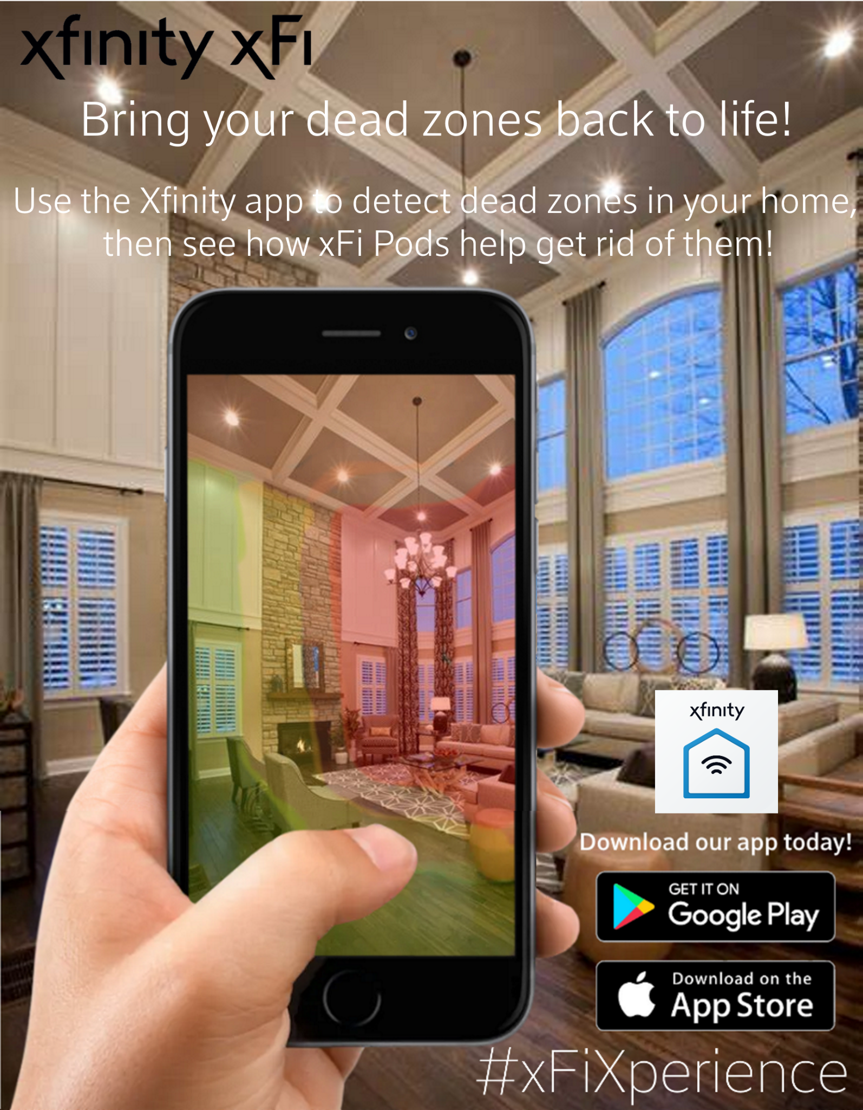

This ad depicts a person using the AR experience in the Xfinity app to locate and identify where the Wi-Fi dead zones are in their house. We plan to place this ad across our Targeted Facebook and Instagram Ads and digital Website Display Ads for the entire duration of the Launch Wave.

## Launch Wave Cost, Impressions, Frequency

### Advertising

#### Cable TV (Primetime TV on MSNBC Nightly News)

* Cost: $1,300,000
* CPM: $17 (Comcast Cost Sheet, 2021)
* Total Impressions: 241,176,471
* Frequency: We suggest running traditional Primetime Cable TV ads on MSNBC Nightly News three times a week, totaling 45 ads over the course of the Launch Wave. Because this phase’s objective is to raise awareness and generate interest in xFi Pods, we want to utilize traditional advertising because it is geared more toward educating the target audience about the brand and the product.

#### Cable TV (Home Improvement (HGTV) Channel)

* Cost: $1,000,000
* CPM: $13 (Comcast Cost Sheet, 2021)
* Total Impressions: 173,076,923
* Frequency: We suggest running traditional Cable TV ads on HGTV three times a week, totaling 45 ads over the course of the Launch Wave. Because this phase’s objective is to raise awareness and generate interest in xFi Pods, we want to utilize traditional advertising because it is geared more toward educating the target audience about the brand and the product.

#### NASCAR Broadcasts (on NBC/Fox)

* Cost: $500,000
* CPM: $13 (Comcast Cost Sheet, 2021)
* Total Impressions: 103,846,154
* Frequency: We suggest running traditional Cable TV ads on NBC and Fox during NASCAR broadcasts three times a week for thirteen weeks, totaling 30 ads over the course of the Launch Wave. Because this phase’s objective is to raise awareness and generate interest in xFi Pods, we want to utilize traditional advertising because it is geared more toward educating the target audience about the brand and the product.

#### Winter Olympics (on NBC)

* Cost: $2,000,000
* CPM: $13.50 (Comcast Cost Sheet, 2021)
* Total Impressions: 148,148,148
* Frequency: We suggest running traditional Cable TV ads on NBC during the Winter Olympics twice a day, totaling 42 ads over the course of the three weeks it is being broadcasted. Because this phase’s objective is to raise awareness and generate interest in xFi Pods, we want to utilize traditional advertising on a Comcast-owned media vehicle because it is geared more toward educating the target audience about the brand and the product.

#### Radio Broadcasts

* Cost: $100,000
* CPM: $8 (Comcast Cost Sheet, 2021)
* Total Impressions: 34,375,000
* Frequency: We suggest running traditional radio broadcasting three times a week for seven weeks, totaling 21 ads over the course of the Launch Wave. Because this phase’s objective is to raise awareness and generate interest in xFi Pods, we want to utilize traditional advertising because it is geared more toward educating the target audience about the brand and the product.

### Digital Advertising

#### Peacock Ads

* Cost: $225,000
* CPM: $22 (Comcast Cost Sheet, 2021)
* Total Impressions: 35,227,273
* Frequency: With frequencies of twice a week, Peacock Ads will total 30 ads shown during the Launch Phase. Peacock Ads are more targeted toward the intended audience, which will aid in spreading awareness about xFi Pods.

#### YouTube Ads

* Cost: $500,000
* CPM: $3.53 (Comcast Cost Sheet, 2021)
* Total Impressions: 331,444,759
* Frequency: With frequencies of twice a week for eleven weeks, YouTube Ads will total 22 ads shown during the Launch Phase. YouTube Ads are a more targeted form of media, which will aid in spreading awareness about xFi Pods among the target audience.

#### Google AdWords (Keyword Search for “Why is my Wi-Fi slow?”)

* Cost: $400,000
* CPM: $19.40 (Comcast Cost Sheet, 2021)
* Total Impressions: 24,226,804
* Frequency: An advertisement will appear any time someone searches for this keyword phase.

#### Google AdWords (Keyword Search for "Mesh Extenders" and "best Wi-Fi mesh")

* Cost: $50,000
* CPM: $19.40 (Comcast Cost Sheet, 2021)
* Total Impressions: 33,505,155
* Frequency: An advertisement will appear any time someone searches for this keyword phase.

#### Website Display Ads

* Cost: $1,250,000
* CPM: $1.53 (Comcast Cost Sheet, 2021)
* Total Impressions: 1,535,947,712
* Frequency: We propose a display ad frequency of three times a week, which results in a total of 45 ads shown throughout the Launch Wave. By placing display ads on the aforementioned home improvement and technology review websites, we hope to build awareness of the product among those who are searching for technology and home improvement products and who may be unaware of xFi Pods.

#### Direct Email

* Cost: $20,000
* CPM: $8 (van Rijn, 2021)
* Total Impressions: 33,505,155
* Frequency: We suggest sending emails to the target audience once every three weeks in the Launch Phase. Although we want to educate consumers of the product offerings and benefits of xFi Pods, we do not want to overwhelm them or crowd their inboxes, especially when we are not offering them sales promotions or specific calls to action. Instead, this email will keep consumers informed and build awareness, but it will not be too frequent that they stop opening and viewing our emails.

### Print Advertising

#### Direct Mail

* Cost: $450,000
* CPM: $220 (“Compare Direct Mail Service Prices in 2021: Cost guide,” 2021)
* Total Impressions: 5,477,273
* Frequency: We recommend sending Direct Mail advertisements once every five weeks. This frequency will be ideal because Direct Mail will be sent to customers a total of three times throughout the Launch Phase. We do not do not want to overwhelm customers by sending Direct Mail too frequently, especially since the CPM of Direct Mail is significantly more expensive than that of other media outlets. Additionally, we do not intend on sending Direct Mail too frequently during this phase since its goal is to garner awareness and interest in the product, rather than an immediate response or action.

### Social Media Advertising

#### Targeted Facebook Ads

* Cost: $750,000
* CPM: $8.71 (Comcast Cost Sheet, 2021)
* Total Impressions: 223,880,597
* Frequency: We propose advertising on this social media platform twice a week. Because Facebook has 1.79B daily active users, the social media platform is widely used. However, despite the high usage rates of Facebook, we do not want to advertise too frequently because it often does not stimulate action from the customers.

#### Targeted Instagram Ads

* Cost: $500,000
* CPM: $7.68 (Comcast Cost Sheet, 2021)
* Total Impressions: 162,760,417
* Frequency: We propose advertising on this social media platform twice a week. Because Instagram has more than 500M daily active users, the social media platform is commonly used. However, despite the high usage rates of Instagram, we do not want to advertise too frequently because it does not always stimulate action from the customers.

#### Ads on Owned Facebook and Instagram Accounts

Although ads on Comcast’s owned Facebook account do not have CPMs, costs, or impressions associated with them, we suggest a frequency of three times a week because they are targeted toward those who are familiar with and interested in the brand since they follow Comcast’s accounts.

## Launch Wave Metrics

### Click through Rates

Through our targeted social media ads, display ads on websites, Google AdWords ads, and display ads on YouTube, how often a customer clicks on our ads and are brought to our website will be one of the best ways to gage how often new consumers are engaging with our content. For example, if our CTR on Google AdWords were to exceed the average of 1.90% (Johnson, 2021), that would tell us that customers are interested in our advertising content and our money is being well spent.

### Bounce Rates

Bounce rates are a good gage of consumer interest because if a user clicks on our ad, sees our website, and immediately leaves, even though we’ve gained their awareness, we failed to capture their attention. We will compare our bounce rate with the Consumer Electronics industry average bounce rate of 44% (Test, 2021). If we receive a bounce rate higher than the industry average, we know that consumers are disinterested in our advertisement, telling us that our marketing efforts are not being well received. On the other hand, a lower-than-average bounce rate indicates that consumers are more willing to browse our website and learn more about xFi Pods.

### Email Open Rates

Similar to bounce rates, email open rates will help to measure the effectiveness of our email marketing. Again, we will compare our email open rate with the industry average of 40% (Comcast Cost Sheet, 2021). If our rate is greater than the industry average, we know that customers are curious about Comcast’s product offerings. However, an email open rate less than the industry average will indicate that the target audience is not interested in or engaged by Comcast’s advertisements.

### Xfinity app Download Rate

Since another aspect of the Launch Wave is to make people aware of our proposed Xfinity AR app experience, one definitive way to see if people are actually interested in these features would be an increase in the amount of people that have downloaded and use the Xfinity app. For example, currently on the App Store, while there are no metrics regarding the exact number of people that have downloaded the app, the Xfinity app is rated #13 under “Utilities” (Comcast Interactive Media, 2021). If, over the course of our Launch Wave, that the Xfinity app were to move up to #10, that would show that a large portion of users have been downloading the app and are satisfied.

# Wave 2: “Shed Sunlight and Expose Dead Zones this Summer” Runs April 18, 2022 through September 4, 2022

## Second Wave Objective

The objective of this wave is to build upon the awareness and interest that was garnered in the first wave, shifting the focus toward creating desire and driving the customer to make purchases. This would be the ideal time of year to promote desire and action because Xfinity sees peak internet usage during June through July, and it experiences the most sign-ups for new internet users during the months of July through September (Comcast Corporation, 2021).

## Second Wave Media & Vehicle Description, Justification and Implementation

### Advertising

#### Primetime TV (MSNBC Nightly News)

#### Home Improvement Channel (HGTV)

#### Radio Broadcasts

#### NASCAR Broadcasts (Fox/NBC)

### Digital Advertising

#### Keyword Search ("Mesh Extenders" and “best Wi-Fi mesh”)

Since we are targeting customers who have moved further down the purchase funnel, we are not focusing on broad paid keyword searches, but rather on more specific keywords related to “Mesh Extenders” and “best Wi-Fi mesh.”

#### Display ads (technology and home improvement websites)

#### Peacock ads

#### YouTube ads

### Print Advertising

#### Direct Mail

### Social Media Advertising

#### Targeted Facebook ads

#### Targeted Instagram ads

#### Owned Instagram

#### Owned Facebook

### Sales Promotions

#### Universal Studios Sweepstakes

In order to catalyze customer purchases, we will start the second phase by promoting an all-expense paid trip for a family to spend a week at Universal Studios in Orlando, FL. Customers who purchase an xFi Pod will be entered into the contest, and a winner will be announced in the last week of July.

#### Fourth of July Weekend Sale

On the weekend of July 4th, 2022, there will be a promotion selling xFi Pods at a $20 discount for one xFi Pod ($99/Pod) and $49 discount for two xFi Pods ($149/2 Pods).

#### Labor Day Weekend Sale

On Labor Day Weekend of 2022, there will be a promotion selling xFi Pods at a $20 discount for one xFi Pod ($99/Pod) and $49 discount for two xFi Pods ($149/2 Pods).

#### Xfinity Technician Bonus Incentive

For this phase, we’ve set aside $100,000 to be distributed to technicians as a bonus/commission for every xFi Pod that they sell to a customer. We hope to motivate the technicians to sell additional xFi Pods by rewarding them with cash bonuses. Harvard Business Review conducted an experiment that dealt with offering bonuses to sales representatives to find any patterns in behavior or motivating factors. Using experiment groups with three different bonuses offered, the experiment found that each experiment group outsold the control group regardless of the type of bonus rewarded (Chung, 2015). This shows that extending bonuses or commissions incentivize most reps to sell more.

## Second Wave Promotional Materials

## Second Wave Cost, Impressions, Frequency

### Advertising

#### Cable TV (Primetime TV on MSNBC Nightly News)

* Cost: $1,200,000
* CPM: $17 (Comcast Cost Sheet, 2021)
* Total Impressions: 241,176,471
* Frequency: We suggest running traditional Primetime Cable TV ads on MSNBC Nightly News once a week, totaling 20 ads over the course of Phase Two. Because the Launch Wave will have established awareness already, this phase will have a lower frequency for traditional advertising media because we want to utilize other media that are geared more toward inspiring the target audience to take action to purchase xFi Pods.

#### Cable TV (Home Improvement (HGTV) Channel)

* Cost: $500,000
* CPM: $13 (Comcast Cost Sheet, 2021)
* Total Impressions: 173,076,923
* Frequency: We suggest running traditional Cable TV ads on HGTV once a week, totaling 20 ads over the course of Phase Two. Because the Launch Wave will have established awareness already, this phase will have a lower frequency for traditional advertising media because we want to utilize other media that are geared more toward inspiring the target audience to take action to purchase xFi Pods.

#### NASCAR Broadcasts (on NBC/Fox)

* Cost: $650,000
* CPM: $13 (Comcast Cost Sheet, 2021)
* Total Impressions: 103,846,154
* Frequency: We suggest running traditional Cable TV ads on NBC and Fox during NASCAR broadcasts once a week, totaling 20 ads over the course of Phase Two. Because the Launch Wave will have established awareness already, this phase will have a lower frequency for traditional advertising media because we want to utilize other media that are geared more toward inspiring the target audience to take action to purchase xFi Pods.

#### 

#### Radio Broadcasts

* Cost: $100,000
* CPM: $8 (Comcast Cost Sheet, 2021)
* Total Impressions: 34,375,000
* Frequency: We suggest running traditional radio broadcasting ads once a week for eleven weeks. Because the Launch Wave will have established awareness already, this phase will have a lower frequency for traditional advertising media because we want to utilize other media that are geared more toward inspiring the target audience to take action to purchase xFi Pods.

### Digital Advertising

#### Peacock Ads

* Cost: $225,000
* CPM: $22 (Comcast Cost Sheet, 2021)
* Total Impressions: 35,227,273
* Frequency: With frequencies of twice a week, Peacock Ads will total 40 ads shown during Phase Two. This is a higher frequency than traditional advertising because Peacock Ads are more targeted toward the intended audience as compared with other media outlets such as Cable TV and radio broadcasts.

#### YouTube Ads

* Cost: $445,000
* CPM: $3.53 (Comcast Cost Sheet, 2021)
* Total Impressions: 331,444,759
* Frequency: With frequencies of twice a week, YouTube Ads will total 40 ads shown during Phase Two. This is a higher frequency than traditional advertising because YouTube Ads are more targeted toward the intended audience as compared with other media outlets such as Cable TV and radio broadcasts.

#### Google AdWords (Keyword Search for "Mesh Extenders" and "best Wi-Fi mesh")

* Cost: $500,000
* CPM: $19.40 (Comcast Cost Sheet, 2021)
* Total Impressions: 33,505,155
* Frequency: An advertisement will appear any time someone searches for this keyword phase.

#### Website Display Ads

* Cost: $750,000
* CPM: $1.53 (Comcast Cost Sheet, 2021)
* Total Impressions: 1,535,947,712
* Frequency: We propose a display ad frequency of four times a week, which results in a total of 80 ads shown throughout Phase Two. By placing display ads on the aforementioned home improvement and technology review websites, we hope to build upon the interest of those who are in the process of searching for technology and home improvement products.

#### Direct Email

* Cost: $15,000
* CPM: $8 (van Rijn, 2021)
* Total Impressions: 33,505,155
* Frequency: We suggest sending emails to the target audience once a week in Phase Two. We are increasing the frequency in this phase because of the shift in the phase’s objectives. This wave is more focused on moving consumers further down the purchase funnel through the use of the Universal Studios Sweepstakes, Fourth of July Weekend, and Labor Day Weekend sales promotions. We will send emails more frequently than the previous phase to encourage interest and participation in these sales promotions, with the hopes of increasing sales of xFi Pods.

### Print Advertising

#### Direct Mail

* Cost: $450,000
* CPM: $220 (“Compare Direct Mail Service Prices in 2021:Cost guide,” 2021)
* Total Impressions: 5,477,273
* Frequency: We recommend sending Direct Mail advertisements once every four weeks. This frequency will be ideal because Direct Mail will be sent to customers a total of five times throughout the phase. We do not do not want to overwhelm customers by sending Direct Mail too frequently, especially because of the expensive CPM of Direct Mail. However, Direct Mail tends to be more effective at driving sales because it includes an immediate call to action, which will be important in order to capitalize on the peak consumption period of Phase Two.

### **Social Media Advertising**

#### Targeted Facebook Ads

* Cost: $600,000
* CPM: $8.71 (Comcast Cost Sheet, 2021)
* Total Impressions: 223,880,597
* Frequency: We propose to continue advertising on Facebook twice a week. We do not want to advertise too frequently on the social media platform since it often does not result in action from the customers.

#### Targeted Instagram Ads

* Cost: $400,000
* CPM: $7.68 (Comcast Cost Sheet, 2021)
* Total Impressions: 162,760,417
* Frequency: We propose to continue advertising on Instagram twice a week. We do not want to advertise too frequently on the social media platform since it often does not result in action from the customers.

#### Ads on Owned Facebook and Instagram Accounts

Although ads on Comcast’s owned Facebook account do not have CPMs, costs, or impressions associated with them, we suggest a frequency of three times a week because they are targeted toward those who are familiar with and interested in the brand since they follow Comcast’s accounts.

### Sales Promotions

The Universal Studios Sweepstakes promotion will occur in this phase and cost $5,000, which is an estimate of the cost for a family of four based on September 2021 prices (Dani, 2021). Because we have accounted for the advertising costs in our traditional advertising costs, this $5,000 solely includes the cost of the trip for a four-person family. Because of this, no CPM exists nor are impressions associated with this sales promotion.

Similarly, the sales promotions on the Fourth of July and Labor Day Weekends exclude the advertising costs since they are also encompassed by the traditional advertising budget for this phase. Therefore, for each of these promotions, we have allotted $50,000 to be set aside to account for selling xFi Pods at a discounted price. Specifically, we plan to sell single xFi Pods at $99 (down from $119) and two xFi Pods at $150 (down from $199).

### 

## Second Wave Metrics

### Sales/Sales through Xfinity app

The ultimate way to determine the effectiveness of our marketing strategy would be a statistically significant increase in the sales of xFi Pods as compared to the previous year. More specifically, one way to measure the effectiveness of our AR app experience would be the amount of customers that purchase xFi Pods directly through the Xfinity app.

### Conversion Rates

Conversion rates would specifically help us identify the effectiveness of our digital and social media content. We can compare conversion rates of specific media and vehicles with each other to identify any patterns that may emerge. For example, if one vehicle outlet has a significantly higher conversion rate than another vehicle, we can prioritize ads on the former vehicle.

# Wave 3: “Bring Your Dead Zones Back to Life” Runs September 5, 2022 through January 1, 2023

## Third Wave Objective

The objective of this wave is to raise awareness and stimulate curiosity among customers who may not have been reached in the first wave, while also continuing to push for customers who already are aware and interested in the product to purchase xFi Pods. This would be an ideal time to do so because Comcast sees its second major peak in internet usage during the winter months of November and December (Comcast Corporation, 2020). This wave will also take advantage of seasonal-themed advertising surrounding Halloween and the Holiday Season.

## Third Wave Media & Vehicle Description, Justification and Implementation

### Advertising

#### Primetime TV (MSNBC Nightly News)

#### Home Improvement Channel (HGTV)

#### Radio Broadcasts

#### NASCAR Broadcasts (Fox/NBC)

### Digital Advertising

#### Keyword Search (“Why is my Wi-Fi slow?”)

Because we are targeting those who may not have been reached in the first wave, we are focusing on broad paid keyword search phrases such as “Why is my Wi-Fi slow?”

#### Keyword Search ("Mesh Extenders" and “best Wi-Fi mesh”)

Since we are again targeting customers who have moved further down the purchase funnel, we are not focusing on broad paid keyword searches, but rather on more specific keywords related to “Mesh Extenders” and “best Wi-Fi mesh.”

### Display ads (technology and home improvement websites)

#### Peacock ads

#### 

#### YouTube ads

### Print

#### Direct Mail

### Social Media

#### Targeted Facebook ads

#### 

#### Targeted Instagram ads

#### 

#### Owned Instagram

#### 

#### Owned Facebook

### Sales Promotions

#### Black Friday Sale

There will be a promotion selling xFi Pods at a $20 discount for one xFi Pod and a $49 discount for two xFi Pods from the weeks of November 7, 2022 through November 28, 2022. Many companies use Black Friday sales as a way to get consumers to buy a product that they would normally spend time comparing prices to find the best option (Yang & Carmon, 2021). With the added incentive of a lower price consumers would be more willing to buy the product that they are already looking for. In 2020, 59% of consumers reported that they were looking for deals on home appliances or tablets, laptops, and PCs. This means that not only were potential customers looking to save on products like the xFi Pod, but also the devices that demand the Wi-Fi coverage that the xFi Pod provides.

#### Xfinity Technician Bonus Incentive

For this phase, we’ve set aside $100,000 to be distributed to technicians as a bonus/commission for every xFi Pod that they sell to a customer.

## Third Wave Promotional Materials

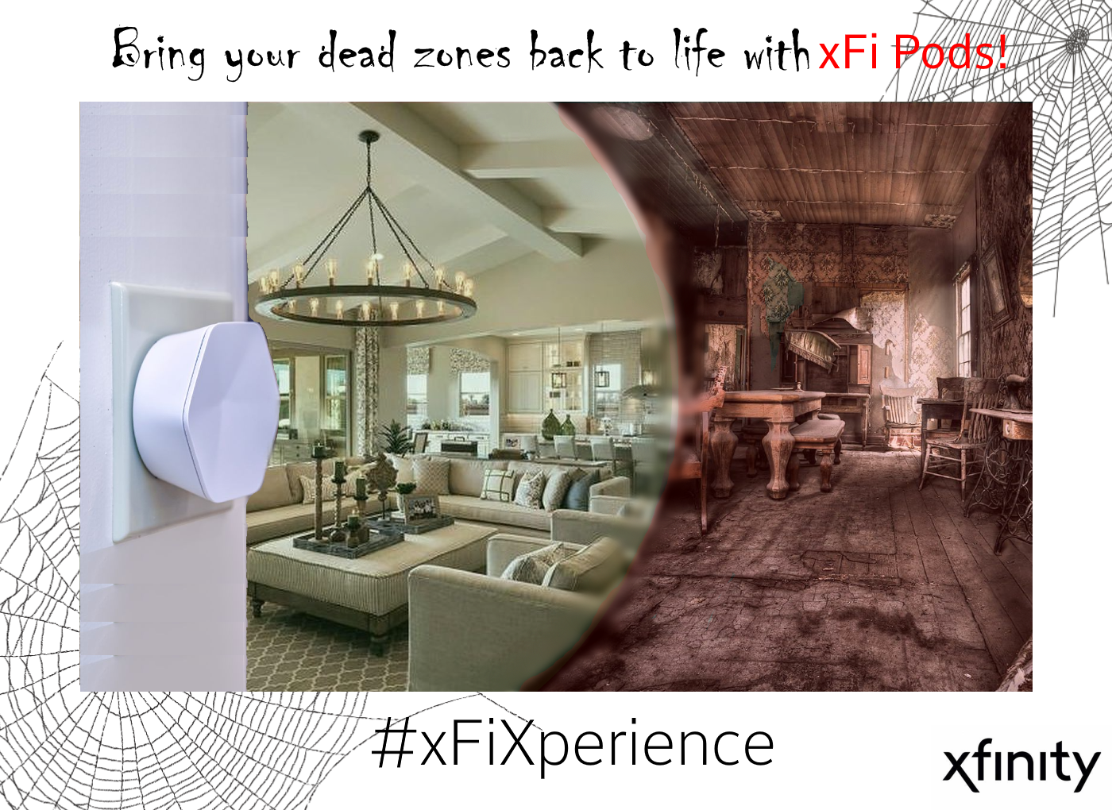

This ad illustrates the improvement of Wi-Fi connectivity from xFi Pods by showing the contrast between a room that has an xFi Pod installed (left) and a room that has dead spots due to a lack of an xFi Pod (right). This contrast is highlighted by the Xfinity app’s AR heat map and has a Halloween-themed twist.

## Third Wave Cost, Impressions, Frequency

### Advertising

#### Cable TV (Primetime TV on MSNBC Nightly News)

* Cost: $1,500,000
* CPM: $17 (Comcast Cost Sheet, 2021)
* Total Impressions: 241,176,471
* Frequency: We suggest that for Phase Three, ads during NBC Nightly News are bumped back up to twice a week in order to reach those in our target market that we may have missed during our first awareness wave.

#### Cable TV (Home Improvement (HGTV) Channel)

* Cost: $750,000
* CPM: $13 (Comcast Cost Sheet, 2021)
* Total Impressions: 173,076,923
* Frequency: Similarly to NBC Nightly News, we suggest that within Phase Three, ads on HGTV are also bumped back up to twice a week.

#### NASCAR Broadcasts (on NBC)

* Cost: $100,000
* CPM: $13 (Comcast Cost Sheet, 2021)
* Total Impressions: 103,846,154
* Frequency: Given that the NASCAR season ends in the first week of November, we suggest continuing advertising once a week until the end of the season, meaning 5 total ads for the duration of Phase Three.

#### Radio Broadcasts

* Cost: $75,000
* CPM: $8 (Comcast Cost Sheet, 2021)
* Total Impressions: 34,375,000
* Frequency: For the majority of Phase Three, we suggest continuing to broadcast radio advertisements twice a week for thirteen weeks. However, during our Black Friday Sales Promotion, we suggest bumping that up to four times a week in order to make potential customers aware of the limited-time opportunity.

### Digital Advertising

#### Peacock Ads

* Cost: $325,000
* CPM: $22 (Comcast Cost Sheet, 2021)
* Total Impressions: 35,227,273
* Frequency: Since Peacock encompasses our target audience, we plan to increase our advertising on this platform to three times a week to push them to make a purchase during the final phase.

#### YouTube Ads

* Cost: $445,000
* CPM: $3.53 (Comcast Cost Sheet, 2021)
* Total Impressions: 331,444,759
* Frequency: During this phase, we plan to keep the frequency of targeted YouTube Ads at twice a week, except from November 7th-28th, in which the frequency will increase to three times a week to make customers aware of our Black Friday Discount.

#### Google AdWords (Keyword Search for “Why is my Wi-Fi slow?”)

* Cost: $70,000
* CPM: $19.40 (Comcast Cost Sheet, 2021)
* Total Impressions: 24,226,804
* Frequency: An advertisement will appear any time someone searches for this keyword phase.

#### Google AdWords (Keyword Search for "Mesh Extenders" and "best Wi-Fi mesh")

* Cost: $100,000
* CPM: $19.40 (Comcast Cost Sheet, 2021)
* Total Impressions: 33,505,155
* Frequency: An advertisement will appear any time someone searches for this keyword phase.

#### Website Display Ads

* Cost: $350,000
* CPM: $1.53 (Comcast Cost Sheet, 2021)
* Total Impressions: 1,535,947,712
* Frequency: Due to the low conversion rates of website display ads and the fact that they are not for inciting action, we plan to cut down frequency of website display ads to two times per week. With that being said, we believe that this new, lower frequency will still be able to raise awareness amongst those that we’ve missed in previous phases.

#### Direct Email

* Cost: $15,000
* CPM: $8 (van Rijn, 2021)
* Total Impressions: 33,505,155
* Frequency: We suggest that similar to Direct Mailing, we would continue to directly email only customers who have not purchased xFi Pods yet at a rate of once a week. During our Black Friday Sale, we will email them twice a week to really push them to make a purchase.

### 

### Print Advertising

#### Direct Mail

* Cost: $305,000
* CPM: $220 (“Compare Direct Mail Service Prices in 2021:Cost guide,” 2021)
* Total Impressions: 5,477,273
* Frequency: In terms of Direct Mail, we would continue to advertise to customers at a rate of once every four weeks, however, we would only be sending mail to customers we know have not purchased xFi Pods yet.

### Social Media Advertising

#### Targeted Facebook Ads

* Cost: $600,000
* CPM: $8.71 (Comcast Cost Sheet, 2021)
* Total Impressions: 223,880,597
* Frequency: On this platform, advertising would increase to three times a week in order to create awareness amongst any customers in our target we may have missed up to this point.

#### Targeted Instagram Ads

* Cost: $350,000
* CPM: $7.68 (Comcast Cost Sheet, 2021)
* Total Impressions: 162,760,417
* Frequency: We would also increase our advertising on this platform to three times a week to create awareness amongst any customers in our target we may have missed up to this point.

#### Ads on Owned Facebook and Instagram Accounts

Although ads on Comcast’s owned Facebook account do not have CPMs, costs, or impressions associated with them, we suggest a frequency of three times a week because they are targeted toward those who are familiar with and interested in the brand since they follow Comcast’s accounts.

### Sales Promotions

#### Black Friday Sales Promotion

From the weeks of November 7th through November 28th, we plan to run a sales promotion selling xFi Pods at a discounted price of one for $99 (down from $119) and two for $150 (down from $199). To account for this loss in revenue, we’ve allotted $100,000 in our Detailed Marketing Budget.

## Third Wave Metrics

Since our third wave shifts back towards a focus on cultivating awareness and interest in those in our target market that may not have been reached in the first phase, some metrics that we used in the Launch wave such as Click Through Rates, Bounce Rates, Email Open Rates, and the Xfinity app Download Rate will be used in a similar way as in the Launch Wave.

While there is a focus on capturing new customers that we missed in the first wave, there is also an emphasis on encouraging those who are already aware of and interested in xFi Pods to make purchases. Some metrics that we will continue to use the same way as in the second wave include Sales, Sales through the Xfinity app, and the Conversion Rates of our digital and social media Ad content. In this final phase, the ultimate metric to measure the success of our year-long advertising campaign will be Sales, as noted by Comcast (Comcast NBCUniversal, 2021).

Detailed Marketing Budget and ROI (Max, Samantha, Cara, Nick)

# Detailed Marketing Budget

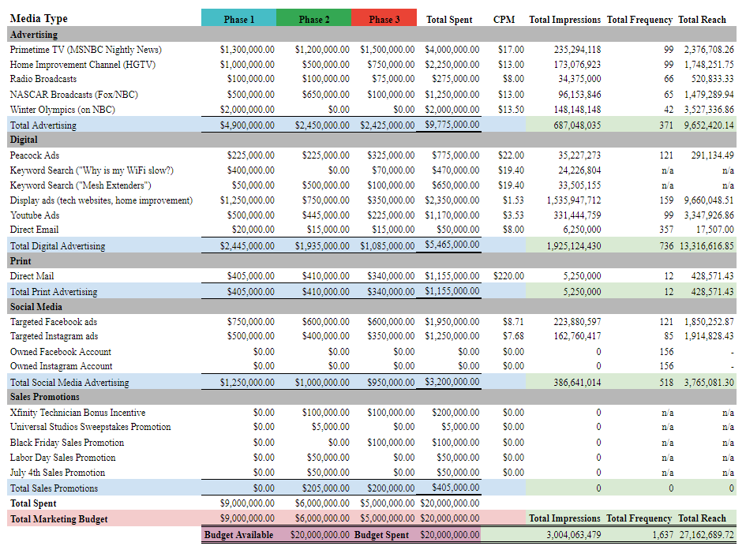

# ROI Calculations

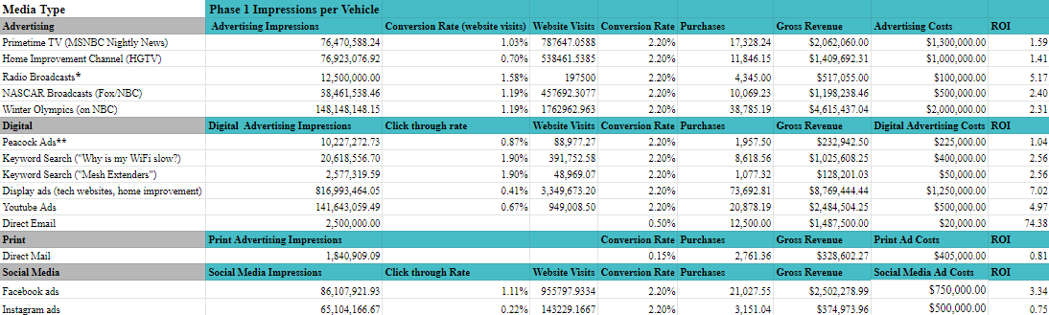

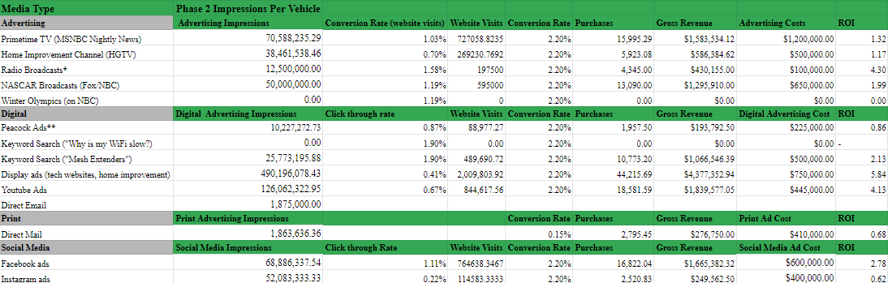

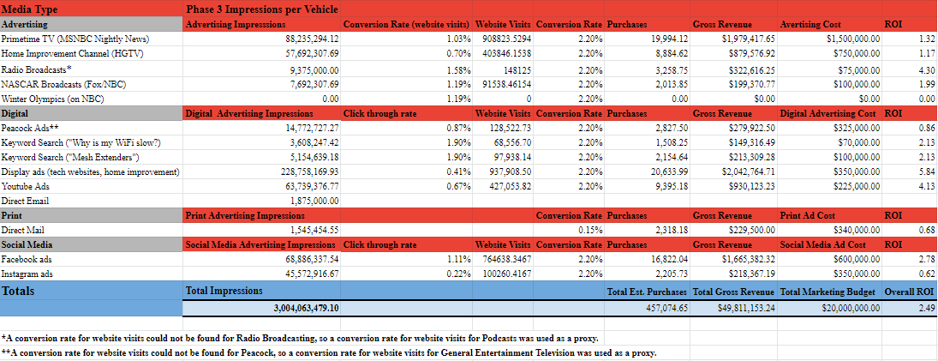

# ROI Discussion

According to our estimates, the overall ROI of our Marketing Budget is 2.46, with an estimated Total Gross Revenue of ~$49M and ~450k xFi Pods sold. An important aspect to note is that for all sales in waves 2 and 3, gross revenue was calculated using the discounted sale price of xFi Pods ($99/unit) for the entire wave, which makes for a more convservative gross revenue estimate.

Summary and Conclusion (Cara)

The rise in remote work and consumer electronic purchases due to COVID-19 presents a unique opportunity for Comcast to showcase its xFi Pods. Because our research suggests that a majority of the target audience is at the top of the purchase funnel, our comprehensive advertising campaign utilizes media such as digital, social, and traditional advertising in order to raise awareness about the product’s offerings and benefits. To do this, we will integrate interactive AR technology into the Xfinity mobile app to enhance the user experience. Coupling our AR-enhanced Xfinity app with xFi Pods provides consumers with solutions for Wi-Fi dead zones before they recognize they have a problem. Employing this AR technology positions Comcast as an industry leader focused on the customer. To achieve the campaign’s ultimate goal of increasing sales and revenue of xFi Pods, we will use direct mailing, sales promotions, and personal selling, along with our proposed BNPL financing option. Employing these strategies further communicates to consumers that Comcast seeks to improve and simplify the lives of consumers. Unified by a priority placed on customer engagement, our campaign conveys Comcast’s customer-centric value as an end-to-end service provider that readily supports the needs of its consumers.

Citations

*24 Direct Mail Statistics To Write Home About - 2021 Edition*. (2021, July 7). SmallBizGenius.

Retrieved November 15, 2021, from

<https://www.smallbizgenius.net/by-the-numbers/direct-mail-statistics/>

Adnams, S. (2021, March 16). *CIOs Need to Embrace Radical Flexibility to Drive the   
 Post-COVID-19 Work Experience*. Gartner. <https://www.gartner.com/document/3999424>.

Adstage. (2020, January). *Paid Media Q1 2020 Media Benchmark Report*. <https://www.adstage.io/resources/q1-2020-ppc-benchmark-report/>.

*Alphabet Inc.* D&B Hoovers. (2021). Retrieved November 4, 2021, from   
<https://app.avention.com/company/a61920e9-7fa0-3f69-9973-9bcf8ec5973b#report/company_corporate_family>.

*Amazon.com, Inc.* D&B Hoovers. (2021). Retrieved November 4, 2021, from https://app.avention.com/company/9dbf588b-b28e-33e4-877b-2df0fdc8cf9e#report/company_corporate_family*.*

*Amazon.com, Inc.* D&B Hoovers. (2021). Retrieved November 4, 2021, from https://app.avention.com/company/9dbf588b-b28e-33e4-877b-2df0fdc8cf9e#report/company_income.

Amazon.com Inc. Form 10-K. (2021). <https://www.sec.gov/ix?doc=/Archives/edgar/data/1018724/000101872421000004/amzn-20201231.html>.

*Amazon eero Pro 6 tri-band mesh Wi-Fi 6 system with built-in Zigbee smart home hub (3-pack)*.   
 Amazon. (2021).   
 <https://www.amazon.com/Amazon-eero-pro-6-3-pack/dp/B085VNCZHZ>.

Armental, M. (2019, February 11). *Amazon to Acquire Home Wi-Fi Company Eero*. WSJ; The Wall Street Journal. <https://www.wsj.com/articles/amazon-to-acquire-home-wi-fi-company-eero-11549927358>.

Arris Team. (2019, January 3). *The Advantages of Tri-Band Routers*. Commscope. <https://www.commscope.com/blog/2019/the-advantages-of-tri-band-routers/>.

Baird, Nikki. (2019, March 20). *What Consumer Adoption of Augmented Reality Means for Retail*. Forbes. <https://www.forbes.com/sites/nikkibaird/2019/03/20/what-consumer-adoption-of-augmented-reality-means-for-retail/?sh=d001c2246240>.

Baker, M. (2021, April 29). *9 Future of Work Trends Post-covid-19*. Gartner. https://www.gartner.com/smarterwithgartner/9-future-of-work-trends-post-covid-19.

Barnes, J. (2020, October 19). *Study: HBO Max and Peacock are Reaching Different Age*

*Groups*. Cord Cutters News. Retrieved November 12, 2021, from

<https://www.cordcuttersnews.com/study-hbo-max-and-peacock-are-reaching-different-ag>

e-groups/

Barua, A. (2021, June 28). *A spring in consumers' steps: Americans prepare to get back to their spending ways*. Deloitte Insights. https://www2.deloitte.com/us/en/insights/economy/us-consumer-spending-after-covid.html.

Benes, R. (2021, October 11). *US Audio Advertising Forecast 2021*. Insider Intelligence. <https://content-na1.emarketer.com/us-audio-advertising-forecast-2021>.

Berman, B., & Pollack, D. (2021). *Strategies for the successful implementation of augmented   
 reality*. ScienceDirect.  
 <https://doi.org/10.1016/j.bushor.2021.02.027>.

Boidman, M.A. et al. (2020, March). *Report Summarizing Select Media and Tech Activity* [PDF document]. <https://www.pjsolomon.com/wp-content/uploads/2020/03/PJ-SOLOMON-Media-Monthly-March-2020.pdf>.

Bureau of Labor Statistics. (2020, July 8). Average daily time spent watching TV per capita in the United States in 2009 and 2019, by age group (in hours) [Graph]. In Statista. <https://www.statista.com/statistics/411775/average-daily-time-watching-tv-us-by-age/>.

CABA. (2021, May 19). Which of the following smart technologies / capabilities are already available in your home? [Graph]. In *Statista*. <https://www.statista.com/statistics/1113170/types-of-smart-home-technologies-in-the-united-states-and-canada-by-frequency/>.

Chevalier, S. (2021, July 8). *Global conversion rate by industry 2021*. Statista. <https://www.statista.com/statistics/1106713/global-conversion-rate-by-industry-and-device/>.

Chung, D. J. (2015, April). *How to Really Motivate Salespeople*. Harvard Business Review. Retrieved November 17, 2021, from <https://hbr.org/2015/04/how-to-really-motivate-salespeople>.

Comcast. (2021, October 12). Comcast Xfinity Privacy Policy. <https://cdn.comcast.com/-/media/Images/cpp-privacy-portal/policy/pdfs/PP_101221.pdf?rev=6af6716a-af15-49de-8223-c6af8a2a708c&la=en>.

Comcast Corporation. (2021) Form 10-Q 2021. Comcast Corporation. <https://www.cmcsa.com/static-files/49db1f02-ffbe-4e8b-b266-3d334f2cf83f>

Comcast NBCUniversal. (2021, September). Xfinity xFi Pods [Powerpoint Slides]. <https://elearning.villanova.edu/webapps/blackboard/execute/content/file?cmd=view&content_id=_3481185_1&course_id=_144219_1>.

Comcast Interactive Media. (2021). *Xfinity* (Version 3.45.1) [Mobile Application]. Comcast Interactive Media. <https://apps.apple.com/us/app/xfinity/id1178765645>

*Compare Direct Mail Service Prices in 2021: Cost guide*. PriceItHere.com. (2021). Retrieved November 12, 2021, from <https://priceithere.com/direct-mail-service-prices/>.

Dani. (2021, March 19). *How much does a universal Orlando vacation cost?* Orlando Informer. <https://orlandoinformer.com/blog/how-much-universal-orlando-vacation-costs/>.

Dun & Bradstreet. (2021). *TP-Link USA Corporation*. <https://www.dnb.com/business-directory/company-profiles.tp-link_usa_corporation.00f45eca47a75bd85a8be9dc987d62cf.html#financials-anchor>.

EffectTv. (2019). NASCAR. <https://yousenditcc.s3.amazonaws.com/NASCAR.pdf>.

EffectTv. (2021a). *HGTV*.

<https://www.effectv.com/sites/default/files/HGTV%20Network%20One%20Sheet_0.pdf>.

EffectTv. (2021b). MSNBC.

<https://www.effectv.com/sites/default/files/MSNBC%20Network%20One%20Sheet_0.pdf>.

Facebook. (October 25, 2021). Number of monthly active Facebook users worldwide as of 3rd quarter 2021 (in millions) [Graph]. In *Statista*. <https://www.statista.com/statistics/264810/number-of-monthly-active-facebook-users-worldwide/>

Federal Communications Commissions. (2010, December). *Broadband decisions: What drives consumers to switch – or stick with – their broadband Internet provider*. Washington, D.C.; Federal Communications Commission.

Foxconn Tech Co Stock Price, News, Quote & History. (2021, November 11). Yahoo! Finance.

<https://finance.yahoo.com/quote/2354.TW/>.

Fry, R. (2020, July 29). *Prior to COVID-19, Urban Core Counties in the U.S. Were Gaining Vitality on Key Measures*. Pew Research Center's Social & Demographic Trends Project. https://www.pewresearch.org/social-trends/2020/07/29/prior-to-covid-19-urban-core-counties-in-the-u-s-were-gaining-vitality-on-key-measures/.

Gomez, V. (2021, August 26). *More Americans now say they prefer a community with big houses, even if local amenities are farther away*. Pew Research Center. https://www.pewresearch.org/fact-tank/2021/08/26/more-americans-now-say-they-prefer-a-community-with-big-houses-even-if-local-amenities-are-farther-away/.

Google. (2021). *Nest Wifi*. Google Store. https://store.google.com/us/product/nest_wifi?hl=en-US.

Guilford, G., & DeBarros, A. (2021, October 17). *Supply-chain bottlenecks, elevated inflation to last well into next year, survey finds*. The Wall Street Journal. <https://www.wsj.com/articles/supply-chain-bottlenecks-elevated-inflation-to-last-well-into-next-year-survey-finds-11634479202?mod=article_inline>.

Henderson, G. (2020, August 24). *How Much Time Does The Average Person Spend On Social Media?* DigitalMarketing. [https://www.digitalmarketing.org/blog/how-much-time-does-the-average-person-spend-](https://www.digitalmarketing.org/blog/how-much-time-does-the-average-person-spend-on-social-media)on-social-media.

*Internet usage of Millennials in the United States*. (2021). Statista. <https://www.statista.com/study/19343/millennials-in-the-us-internet-und-online-shopping--statista-dossier/>.

Johnson, J. (2021, June 1). *Google Search CTR in the U.S. 2020*. Statista. Retrieved November 16, 2021, from <https://www.statista.com/statistics/1240623/google-search-ctr-usa/>.

Leichtman Research Group. (2021, May 18). Number of broadband internet subscribers in the United States from 1st quarter 2011 to 1st quarter 2021, by cable provider (in 1,000s) [Graph]. In *Statista*. Retrieved November 17, 2021, from <https://www.statista.com/statistics/217348/us-broadband-internet-susbcribers-by-cable-provider/>

Linksys. Dual-Band Wi-Fi 6 Range Extender. (2021).

<https://www.linksys.com/us/wireless-wi-fi-range-extenders/dual-band-wifi-6-range-extender-ax1800/p/p-re7350/>

Lo, B. (n.d.). *Digital Trends - Fall: Incl Impact of COVID-19 - US - October 2020*. Mintel Group Ltd. [https://reports.mintel.com/display/987240/?fromSearch=%3Ffilters.category%3D138%26last_filter%3Dcategory#](https://reports.mintel.com/display/987240/?fromSearch=%3Ffilters.category%3D138%26last_filter%3Dcategory).

Maas, J., & Baysinger, T. (2021, July 29). *Peacock Reaches 54 Million Signups, 20 Million*

*Monthly Active Accounts*. The Wrap. Retrieved November 12, 2021, from

<https://www.thewrap.com/peacock-subscribers-signups-54-million-the-office-dr-death/>

Masters, K. (2019, March 20). *89% of consumers are more likely to buy products from Amazon than other e-commerce sites: Study.* Forbes. https://www.forbes.com/sites/kirimasters/2019/03/20/study-89-of-consumers-are-more-likely-to-buy-products-from-amazon-than-other-e-commerce-sites/?sh=2a1a9ce84af1.

McKinsey & Company. (2021, October 18). *US consumer sentiment and behaviors during the coronavirus crisis.* McKinsey & Company. https://www.mckinsey.com/business-functions/marketing-and-sales/our-insights/survey-us-consumer-sentiment-during-the-coronavirus-crisis.

*Mergent Online - Annual Reports : Alphabet Inc.* (2021). Retrieved 12 September 2021, from <https://www.mergentonline.com/companyannualreports.php?compnumber=109717>.

*Mergent Online - Company Detail : Alphabet Inc.* (2021). Retrieved 10 September 2021, from <https://www.mergentonline.com/companydetail.php?compnumber=109717&pagetype=synopsis>.

*Mergent Online - Company Detail : Amazon.com Inc*. (2020). Retrieved 10 September 2021, from <https://www-mergentonline-com.ezp1.villanova.edu/companydetail.php?compnumber=91098&pagetype=synopsis>.

*Mergent Online - Company Detail : Netgear Inc*. (2021). Retrieved 4 November 2021, from <https://www.mergentonline.com/companyfinancials.php?compnumber=107240>.

Mickle, T. (2021, August 13). Sonos Scores Legal Win in Patent Battle With Google. The Wall Street Journal. <https://www.wsj.com/articles/sonos-scores-legal-win-in-patent-battle-with-google-11628887424?mod=searchresults_pos3&page=1>.

Mlitz, K. (2021, October 25). *It spending growth by category 2021 - COVID-19 impact*. Statista. https://www.statista.com/statistics/1106083/it-spending-growth-by-category/.

Moses, J. (2021, April). *Internet Service Providers in the US*. IBISWorld. <https://my.ibisworld.com/us/en/industry/51711d/products-and-markets>.

NapoleonCat. (2021, August 1). Distribution of Facebook users in the United States as of July 2021, by age group. In *Statista*.

*NETGEAR Armor - Resources: Protect Home Networks*. NETGEAR. (2021). https://www.netgear.com/home/services/armor/resources/#purchase-armor-qa.

NETGEAR Inc. Form 10-K. (2021). <https://www.sec.gov/ix?doc=/Archives/edgar/data/1122904/000156459021006094/ntgr-10k_20201231.htm>.

NMHC. (November 1, 2020). Distribution of residents who live in rental accommodation in the United States in 2019, by age [Graph]. In *Statista*. Retrieved November 17, 2021, from <https://www.statista.com/statistics/743445/share-of-residents-who-are-renting-usa-by-age/>.

Pi Datametrics. (2021, July 29). Leading electrical retail websites in the United States during the 2nd quarter 2021, by share of voice [Graph]. In *Statista*. <https://www.statista.com/statistics/1253964/leading-electrical-websites-by-sov-united-states/>.

Pyke, Werner. (2021, 11 November). Drive Sales with a Buy Now, Pay Later Payment Option. *Electrum Payments*. <https://electrum.co.za/drive-sales-with-a-buy-now-pay-later-payment-option/>.

Radio Advertising Bureau. (June 28, 2021). Radio use among high income adults in the United States as of June 2021, by gender [Graph]. In *Statista*. from <https://www.statista.com/statistics/252196/radio-use-among-high-income-adults-in-the-us-by-gender/>

Radio World. (2021, March 16). *Most common audio sources used in the car in the United States from 2018 to 2021.*

Reagan, Courtney. (2021, 27 September). Retailers Bid Farewell to Layaway, as Shoppers Embrace Buy Now, Pay Later Options. *CNBC*, CNBC, <https://www.cnbc.com/2021/09/25/why-retailers-are-embracing-buy-now-pay-later-financing-services.html>.

Schlesinger, J. M., & Tracy, R. (2021, August 11). *U.S. government wants a greater role in how Americans access internet*. The Wall Street Journal. <https://www.wsj.com/articles/u-s-government-set-for-greater-role-in-how-americans-access-internet-11628674423?mod=searchresults_pos5&page=1.>

Smith, A., & Anderson, M. (2016, December 19). *2. Online reviews*. Pew Research Center:

Internet, Science & Tech.

<https://www.pewresearch.org/internet/2016/12/19/online-reviews/>

Statista. (2021a, June 2). *Leading Radio Stations in Washington, D.C., in October 2020, by ratings.*

Statista. (2021b, June 28). *Leading Radio Stations in Philadelphia, United States, in October 2020, by ratings.*

Statista Research Department. (2017, June 9). *Share of consumers who found bulk mail/direct mail advertising to be helpful in the United States as of May 2017*. In *Statista*.

Statista Research Department. (2021a, September 7). *Instagram: distribution of global audiences 2021, by age group*.

Statista Research Department. (2021b, October 19). YouTube usage penetration in the United *States 2020, by age group*. <https://www.statista.com/statistics/296227/us-youtube-reach-age-gender/>.

Takiff, J. (2020, December 18). *Review of the Xfinity Gen 2 Xfi pods*. Techlicious. Retrieved November 18, 2021, from <https://www.techlicious.com/review/review-of-gen-2-xfinity-xfi-pods/>.

Test, L. (2021, September 30). 2021 *Digital Experience Benchmarks by Industry*. Contentsquare. <https://contentsquare.com/blog/2021-digital-experience-benchmarks-by-industry/>.

Timiraos, N. (2021, November 3). *Fed Dials Back Bond Purchases, Plots End to Stimulus by June*. The Wall Street Journal.   
<https://www.wsj.com/articles/fed-dials-back-bond-purchases-plots-end-to-stimulus-by-june-11635962417>.

TP-Link. (2021a). *Deco*. <https://www.tp-link.com/us/deco-mesh-wifi/#deco-how-it-works>.

TP-Link. (2021b). *Deco M9 Plus Smart Home Device Compatible List*. https://www.tp-link.com/us/Deco-M9-Plus/compatibility/.

U.S. Bureau of Labor Statistics. (2020, September 1). *Comparing characteristics and selected expenditures of dual- and single-income households with children : Monthly labor review*. U.S. Bureau of Labor Statistics. <https://www.bls.gov/opub/mlr/2020/article/comparing-characteristics-and-selected-expenditures-of-dual-and-single-income-households-with-children.htm.>

US Census Bureau. (2019). ACS 1-Year Estimates Selected Population Profiles [Table]. Retrieved November 17, 2021, from <https://data.census.gov/cedsci/table?t=Age%20and%20Sex%3AEarnings%20%28Individuals%29%3AIncome%20%28Households,%20Families,%20Individuals%29%3AOwner%2FRenter%20%28Householder%29%20Characteristics&g=0300000US1,2,5&tid=ACSSPP1Y2019.S0201&hidePreview=true>

US Census Bureau. (2021, September 14). Percentage distribution of household income in the U.S. in 2020 [Graph]. In *Statista*. Retrieved November 17, 2021, from <https://www.statista.com/statistics/203183/percentage-distribution-of-household-income-in-the-us/>

iSpot.tv. (n.d.) *Using TV Conversion Analytics to Increase Sales* [PDF document]. <https://thecmoclub.com/wp-content/uploads/2017/07/TV-Conversion-Case-Study-iSpot.pdf>.

van Rijn, J. (2019, May 22). *Cost per Mille (CPM)*. Email Vendor Selection. <https://www.emailvendorselection.com/cost-per-mille-cpm/>.

Wall Street Journal. (2021, November 11). Foxconn Technology Co. Ltd.. Financial Statements - WSJ. *The Wall Street Journal.* <https://www.wsj.com/market-data/quotes/TW/2354/financials>

Wang, Yifan. (2021, March 30). Apple Supplier Foxconn’s 2020 Profit Slid 12%. MarketWatch.

[https://www.marketwatch.com/story/apple-supplier-foxconns-2020-profit-slid-12-203-30-24854434](https://www.marketwatch.com/story/apple-supplier-foxconns-2020-profit-slid-12-2021-03-30-24854434)

Williams, R. (2018, April 6). *Ikea Place Ranks as No. 2 Free ARKit app*. Marketing Dive.

<https://www.marketingdive.com/news/ikea-place-ranks-as-no-2-free-arkit-app/520761/>.

Wolf, Michael J. (2020, August 7). “How Covid-19 Has Transformed the Amount of Time We Spend Online.” *The Wall Street Journal*.

[www.wsj.com/articles/how-covid-19-has-transformed-the-amount-of-time-we-spend-online-01596818846?mod=hp_jr_pos1](http://www.wsj.com/articles/how-covid-19-has-transformed-the-amount-of-time-we-spend-online-01596818846?mod=hp_jr_pos1).

Xfinity. (n.d.). *xFi Pod*. <https://www.xfinity.com/learn/internet-service/wifi/xfi-pod>.

xFi Xperts (2021, October). *xFi Xperts Primary Research Survey* [Qualtrics]. Villanova School of Business.

Xfinity. (n.d.). *All Xfinity Stores & Comcast Service Centers.* Xfinity. <https://www.xfinity.com/local/>

Xfinity. (2021, October 19). *Xfi Pods Frequently Asked Questions*. Xfinity Help & Support. <https://www.xfinity.com/support/articles/xfi-pods-faqs>.

Xfinity Chat Agent. (2021). Xfinity internet: Fastest WIFI speeds and the best coverage. Retrieved November 18, 2021, from <https://www.xfinity.com/learn/internet-service?CMP=KNC-43700053503822914-GOOGLE-251733430739-c-xfinity+xfi-p-Xfi_BR_Phrase_North&amp;gclid=CjwKCAiA7dKMBhBCEiwAO_crFM_TNKJu4OBb0wj7wSuS4eq0ryyNfttr6W0gbdRLcQ3CS3ru1NSk4xoCmEwQAvD_BwE&amp;gclsrc=aw.ds>.

Xiaomi. (2021, January 6). New survey finds 70% of consumers improved home during COVID-19, more than half used smart devices. https://www.prnewswire.com/news-releases/new-survey-finds-70-of-consumers-improved-home-during-covid-19-more-than-half-used-smart-devices-301201817.html.

Yang, H., & Carmon, Z. (2021, November 16). Make Black Friday a More Exciting Online Experience. Harvard Business Review. <https://hbr.org/2021/11/make-black-friday-a-more-exciting-online-experience>

YouGov. (n.d.). *Shaun White Popularity & Fame*. Retrieved November 6, 2021, from <https://today.yougov.com/topics/international/explore/sport>.

Appendix

#### 1A: Please tell us at what times of day you find yourself at home using the internet most? Is it after a certain activity? Is it a part of your bedtime or morning routine, etc.?

Many of the respondents said that they use the internet the most either in the morning before they go to work or in the evenings after work to decompress after their days. This data is important because it provided us with some insight for what themes we could appeal to in our marketing campaign.

#### 2A: What do you typically use your home internet for? (Work, school, video games, watching shows, etc.)

The most repeated responses to this question were work, video games, and streaming videos. Given the fact that more people are working from home now than before the pandemic, this makes a lot of sense and shows why something like xFi Pods are so important for making sure one has a stable WiFi connection.

#### 3A: Please tell us about your biggest concerns or the biggest problems you face regarding in-home WiFi and internet services.

Many respondents complained about having poor connection, a few of those specifically cited having one or more dead zones throughout their house. These results are important because it shows that some do have an idea of the problem they have that could possibly be solved by the xFi Pods.

#### Table 1A: How familiar are you with the product known as a WiFi Extender (sometimes called a WiFi mesh)

|  |  |
| --- | --- |
| Not Familiar | 3 |
| Somewhat unfamiliar | 1 |
| Neutral | 13 |
| Somewhat familiar | 59 |
| Very familiar | 36 |

95 out of 119 people who responded to this survey said that they were at least somewhat familiar with the product WiFi Extender. On the other end, 4 of the respondents responded that they were at least somewhat unfamiliar with the product WiFi Extender.

#### Table 2A: Do you currently use a WiFi Extender or WiFi Mesh?

|  |  |
| --- | --- |
| I am not sure | 15 |
| No | 56 |
| Yes (please specify brand | 37 |

37 of our respondents said that they were currently using a WiFi Extender or WiFi Mesh while 56 of the respondents said that they did not currently use a WiFi Extender or WiFi Mesh.

#### Table 3A: Brand of WiFi extender used.

|  |  |
| --- | --- |
| **Brands** | **Number of Respondents** |
| NETGEAR | 5 |
| TP LINK | 4 |
| linksys | 3 |
| Google nest | 2 |
| Amazon Eero | 2 |
| jio | 1 |
| Airtel | 1 |
| Devolo | 1 |
| Asus | 1 |

It is important to note that not everyone from the previous question listed the WiFi extender that they have, and it is also unspecified whether the WiFi extenders are mesh systems or not.

The most popular brand for WiFi Extender or WiFi Mesh is NETGEAR with 5 out of the 20 respondents using that brand.

#### Table 4A: How Satisfied are you with your current WiFi Extender?

|  |  |
| --- | --- |
| Very dissatisfied | 3 |
| Somewhat dissatisfied | 2 |
| Neither dissatisfied nor satisfied | 22 |
| Somewhat satisfied | 47 |
| Very satisfied | 32 |

The majority of people who are currently using a WiFi Extender are somewhat satisfied with their current set-up.

#### Table 5A: How familiar are you with each of the following service providers and products mentioned below?

|  |  |  |  |  |  |
| --- | --- | --- | --- | --- | --- |
| **Brand** | **Not at all Familiar** | **Somewhat Unfamiliar** | **Neither familiar nor unfamiliar** | **Somewhat Familiar** | **Very Familiar** |
| Google Nest | 3 | 3 | 11 | 59 | 28 |
| Amazon Eero | 9 | 5 | 11 | 40 | 39 |
| xFi Pods | 9 | 5 | 28 | 40 | 22 |
| NETGEAR | 3 | 6 | 20 | 49 | 26 |

xFi Pods scored a 40/104 (lowest) for customers that had some familiarity with the product, and a 22/104 for customers that were very familiar with the product, making them the lowest amongst competitors in terms of product recognition here.

#### Table 6A: Who is your current internet service provider?

|  |  |
| --- | --- |
| Verizon | 39 |
| AT&T | 21 |
| Comcast Xfinity | 21 |
| Cox Communications | 13 |
| Other, please specify | 9 |

Verizon appears to be the most popular ISP amongst our surveyees.

#### Table 7A: Please tell us how much you agree or disagree with each of the following statements regarding home internet use.

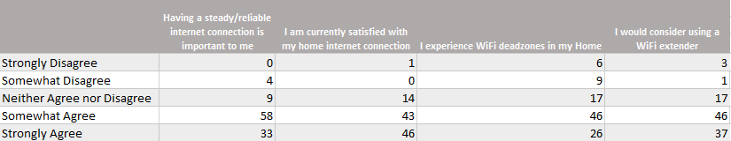

These questions tell us that most people find having reliable internet important, most people are currently satisfied with their ISPs, most people somewhat experience dead zones in their homes, and a lot of people would consider buying a WiFi extender.

#### Table 8A: Please tell us how much you agree or disagree with each of the following statements.

These questions tell us where people place their priorities in terms of choosing an ISP and internet safety, and they show that people *do* value their online privacy, and in some cases would be willing to pay a premium to companies that preserve it. 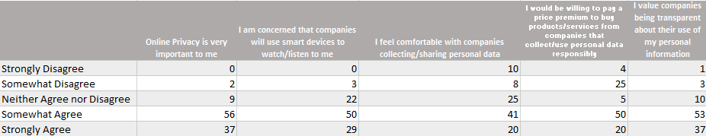

#### Table 9A: When having an at-home tech issue, which would you be most likely to consult for a solution?

|  |  |  |  |  |  |
| --- | --- | --- | --- | --- | --- |
|  | **Call the Company's Customer Service** | **Search for a solution on Google or another Search Engine** | **Look for a video on Youtube that could show a solution** | **Visit the product/service's company website and search for a solution there** | **Ask a family member or friend for help** |
| Very unlikely | 1 | 1 | 1 | 0 | 5 |
| Somewhat unlikely | 5 | 3 | 1 | 2 | 7 |
| Neither unlikely nor likely | 7 | 19 | 23 | 20 | 15 |
| Somewhat likely | 63 | 41 | 54 | 53 | 49 |
| Very likely | 28 | 40 | 25 | 29 | 28 |

The majority of people would be very likely to search for a solution on Google or another Search Engine. A large number of people also thought that they would be somewhat likely to either call the company’s customer service or look for a video on Youtube that could show a solution.

#### Table 11A: Which best describes your place of residence?

|  |  |
| --- | --- |
| City | 63 |
| Rural | 17 |
| Suburb | 20 |

The majority of survey respondents (63/100) live in city-like areas, which does not help us gain insight into our target audience that reside in the suburbs.

#### Table 12A: Which best describes your living situation?

|  |  |
| --- | --- |
| Apartment | 49 |
| Multi-story house | 5 |
| Single-story house | 24 |
| Townhouse | 22 |

The majority of survey respondents (49/100) live in apartments and the minority (5/100) live in a multi-story house.

#### Table 13A: How many stories/levels does your home have (not including the basement)?

|  |  |
| --- | --- |
| 1 | 30 |
| 2 | 48 |
| 3 | 13 |
| 4 or more | 9 |

The majority of respondents (48/100) live in homes that have 2 stories/levels.

#### Table 14A: Does your home have a basement?

|  |  |
| --- | --- |
| No | 28 |
| Yes | 72 |

We asked this question to gain insight as to the layout of people’s homes, which would help us determine their susceptibility to dead zones, and the majority of survey respondents (72/100) have basements.

#### Table 15A: How many people in your house regularly use the internet?

|  |  |
| --- | --- |
| 1 | 9 |
| 2 | 39 |
| 3 | 28 |
| 4 or more | 24 |

The majority of people (39/100) have 2 people in their house that regularly use the internet.

#### Table 16A: Please tell us which of the following best describes your household income (of all earning members combined that live in your household).

|  |  |
| --- | --- |
| $200,000 or above | 2 |
| $150,000 to $199,999 | 4 |
| $100,000 to $149,999 | 7 |
| $75,000 to $99,999 | 24 |
| $50,000 to $74,999 | 26 |
| $25,000 to $49,999 | 30 |
| Below $25,000 | 6 |

The majority of our respondents (26/99) have a combined income of $50,000 to $74,999.

#### Table 17A: Approximately how many square ft. is your home?

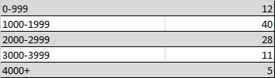

We asked this question to gain insight as to the layout of people’s homes, which would help us determine their susceptibility to dead zones, since people with larger homes are more susceptible. Since the majority of our respondents

#### Chart 1A: Which home internet devices do you frequently use? (Check all that apply)

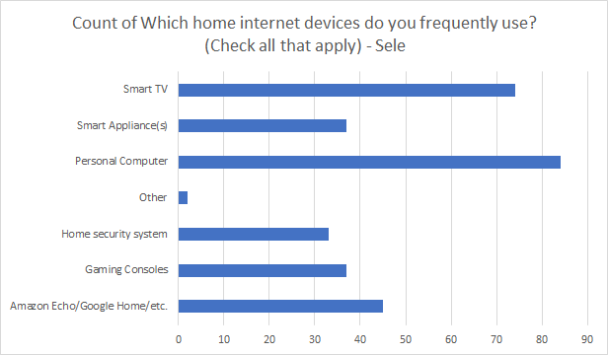

The most common internet devices that people use on their WiFi are personal computers and Smart TV’s and appliances. Also common are home security systems, gaming consoles. Knowing the devices people have connected to the WiFi could help determine the optimal locations for xFi Pods.

#### Chart 2A: Which of the following are your top 3 preferred stores/marketplaces for small electronic purchases?

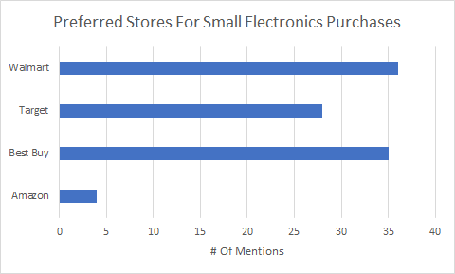

Most respondents purchased their smaller electronic goods from brick and mortar stores; Walmart was cited the most, while Best Buy and Target were not far behind. Amazon, the online retailer, was only selected by four respondents as one of their preferred retailers for electronic devices.

#### Chart 3A: How many devices do you regularly use the internet on? Use your best guess.

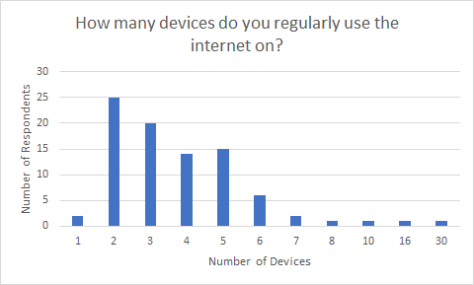

A majority of the respondents had less than 7 devices reportedly connected to their internet. Other respondents had a much higher estimate, which could possibly be due to a misunderstanding of the question.